7/24/13

We are having an interesting summer. In the last five weeks, we set or tied the record for total number of species four times and we have been doing it in the abyss. Prior to this summer, weeks 26 - 40 carried no records exceeding 19. We now have two exceeding 20. For this week, week 30, the old record, set in 2007, was 19, a freaky good score for deep summer. We finished the walk at 21, a new record and far above the old record low of 9 and the median of 13.

See the plots at http://birdwalks.caltech.edu/bird_data/species_time.html and
http://birdwalks.caltech.edu/bird_data/two_plots.htm

One weakness of the walk was a general lack of soaring birds. I often extol the speck scooping eyes of Viveca because she seems to have an uncanny ability to pick up tiny aberrations in the sky but this time it was Vicky who picked up the speck as we were walking up Wilson. Shape and relatively light coloring said buteo but it was quite far away and we were unable to pull the more likely than not juvenile red tailed hawk into a specific species.

We had two major highlights. The first highlight came along the steps of Prufrock where we saw a pair of dark eyed juncos, one adult and a juvenile, hopping in tandem as if tied by a string. In a sense, they were as the juvenile must be highly motivated to learn the tough art of living. Soon, there will be no free lunches. Week 30 is the latest ever sighting of the season for a dark eyed junco. Prior to 2013, the latest spring sighting was always before week 18, which is consistent with winter residence and spring migration, but not with breeding residence. This year, we have a collection of late sightings (weeks 18, 20, 22, 29, and 30) that undoubtedly reflects the presence of a breeding pair of birds outside Prufrock. Are they trying for a second brood? With a little luck, we will get our first ever August sighting of a dark eyed junco.
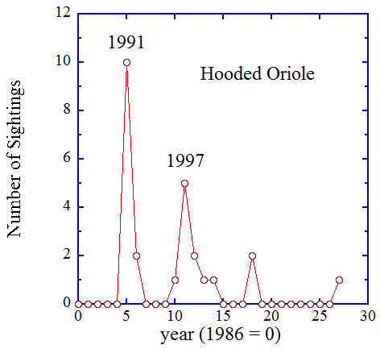
Counting this week, there have been 77 weeks with dark eyed junco sightings on the Caltech bird walk [i.e., a 6 % probability bird overall, though substantially higher than that in winter and much lower (think zero) in the summer]. Our second highlight comes from an even less common species. Viveca caught sight of this bird perched near the outer edge of a sycamore near the Red Door. It didn't stay in place for long but it did yield enough of a look to call it a female or juvenile hooded oriole, our 60th new species of the year. We have only 24 previous sightings of hooded orioles, making this a 2% bird for us but nearly half of these sightings came in a one big splash in 1991, the first year a hooded oriole was seen on the walk. This was almost certainly due to a pair nesting on or very near to campus in 1991, most likely in a local palm tree. Hooded orioles, like all icterids (blackbirds), like to make pendulous nests that hang from underneath fronds or branches. Hooded orioles are particularly fond of Mexican fan palms, which are fairly common in our area.

We had five sightings of hooded orioles in 1997, presumably reflecting a similar but somewhat less favorable arrangement than we had in 1991. That's 15 of our 25 hooded oriole sightings concentrated in just two years, which leaves us lucky to see a hooded oriole in most years. Outside the anomalous years of 1991 and 1997, we have a less than 1% probability of seeing a hooded oriole. In fact, we hadn't seen one since 2004, nearly a decade ago. This bird was an unexpected and welcome visitation, however short.

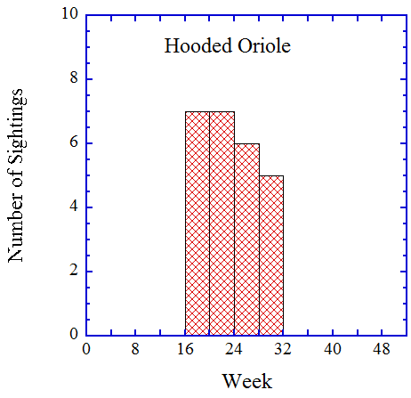
As an oriole factoid, I suggest a little muscle moment. Most birds can generate much stronger forces clamping down on something than they can in opening their beaks. This is an optimization for securing prey or cracking open those nuts or seeds. Orioles take a different approach. They can apply greater pressure in opening their beaks. This "gaping" ability allows them to prise things apart and expose edibles that other birds would not even consider trying to get at. Having an exclusive resource niche means that you have an extra survival tool.

From the histogram of Caltech sightings by week, it is clear that the orioles are at or passing through Caltech in a tightly constrained window between weeks 16 and 31. Based on general migration timing, we might reasonably expect a pulse for fall migration spreading around week 40 or so but we have yet to sample it. The Caltech orioles we have seen are here for the business of breeding and they belong to Mexico or Central America for the rest of the year.

The date: 7/24/2013
The week number: 30
The walk number: 1205
The weather: 83°F, sunny
The walkers: John Beckett , Vicky Brenan, Viveca Sapin-Areeda
The birds (21):

1 Northern Mockingbird
4 Mourning Dove
1 House Finch
2 Anna's Hummingbird
2 Acorn Woodpecker
8 American Crow
3 Yellow-chevroned Parakeet
8 Red-masked Parakeet
1 Black Phoebe
2 Black-chinned Hummingbird
2 Hummingbird, Selasphorus
1 Red-whiskered Bulbul
2 Red-crowned Parrot
1 Band-tailed Pigeon
1 Hawk, species (buteo)
5 Lesser Goldfinch
2 Common Raven
2 Dark-eyed Junco
1 Spotted Towhee
1 Hooded Oriole
3 Bushtit

--- John Beckett

Respectfully submitted,
Alan Cummings,
7/29/13

