7/17/13

For the first time in a month, we have no record species totals to report. We saw 14 species, two below the record of 16, set in 2002, and two above the median.

See the plots at http://birdwalks.caltech.edu/bird_data/species_time.html and
http://birdwalks.caltech.edu/bird_data/two_plots.htm

Although I intend to spend a considerable amount of space discussing a non-walk issue, the walk itself was not without amenities. We did well with hummingbirds. The base is provided by the hummingbird lady outside Tournament Park, who is currently maintaining four or five feeders and several sugar drunk hummingbirds The feeders are a long distance view for us but we readily accounted for all three of our standard summer species (Anna's, Allen's, which we label as the more generic Selasphorus, and black chinned). Anna's are relatively common elsewhere on campus and we saw a black-chinned hummingbird by the Health Center but we would have missed the Selasphorus without those feeders.
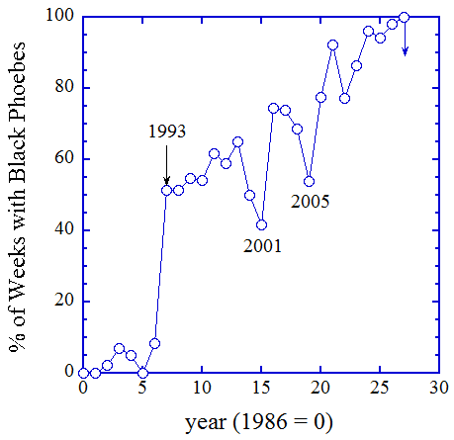
Last week we had three birds and one species to report out of the Health Center stop. This week, Alan picks up on a hummingbird, which draws him across the street, hoping for something other than an Anna's. He gets a female black-chinned hummingbird for his troubles. Then a woodpecker curls around a tree just a few meters away. The bird ignores him but reveals enough of his head to brand him as a downy. A black phoebe darts in. He sees the hummingbird and attacks it. She zips out of reach. He sees the downy and attacks it. The woodpecker drops almost to ground level and twirls around the tree, reminiscent of a squirrel. The black phoebe perches nearby for a moment but he then sees another bird in the crook of a tree and shoots off towards it. A juvenile dark-eyed junco is so surprised by the assault that he flutters up and backwards, then flits a couple of feet away before landing further up on one of the main branches. The phoebe is already gone.

Usually, black phoebes are pretty laissez faire about other species in their territory, which makes me think that this was a recently fledged juvenile. He has probably been driven from a spot or two at the point of a beak. He has grasped the idea that good territories need to be defended but he hasn't quite figured out who they need to be defended from. Alan suggested that we take him along for the rest of the walk and let him flush birds for us. The phoebe declined our offer but I have nevertheless made him an honorary walker. Had he taken up half or more of the walk with us, he would have become official walker # 145. As shown in the first figure, black phoebes have done very well on campus over the last three decades, evolving from being a rare capture through the 1980s, to a species that you see almost every week. Last year, we actually had more weeks graced by black phoebes (51) than crows (48).

Normally, the walk report is at least motivated by the events of the walk but this time, I want to discuss an extraordinary sighting that George Rossman, who is an occasional walker, had a couple of hours before the walk. George is in a second floor office in Arms (Geology) overlooking the quad when he looks out the window at an oak and sees a "WHAT IS THAT?????!!!!!!" It's a crow with grayish white wings. It's a very strange looking animal but he knows without a doubt that this is a crow because there is a second, very normal looking crow in the same tree, providing a perfect comparison for size, structure and coloring. George races upstairs to find me (I wasn't there) and to grab a camera. He gets back just in time to see the crows fly off. He didn't get a photo, unfortunately, but he did get a good view of the birds as they headed west. Strange crow's wings appear nearly all white from below.

Now, I want to immediately dismiss the idea that George didn't see what he said he saw. George is a highly reliable observer and, yes, he knows what a magpie looks like. I asked him to find a couple of images on the web that best described the bird he saw and the two photos below are what he came up with. These can be found at http://www.birdforum.net/attachment.php?s=ed89b6db130b08ddda32699317ac8d25&attachmentid=68704&d=1168459434 and http://www.ar15.com/archive/topic.html?b=1&f=5&t=1141732. Now, the analogy represented by these photos is imperfect. The wings on George’s bird, when perched, were more of a gray than the bright white indicated by the bird on the left but the large patches are true to his bird. The photo on the right shows a similar looking bird taken from below. In the good lighting, the white of George's bird extended all the way to the tips of the feathers on the wing. According to Alan, there may have had a second sighting of George's bird in Pasadena, so there's a chance that this bird will stick around the area long enough to be seen by many of us.
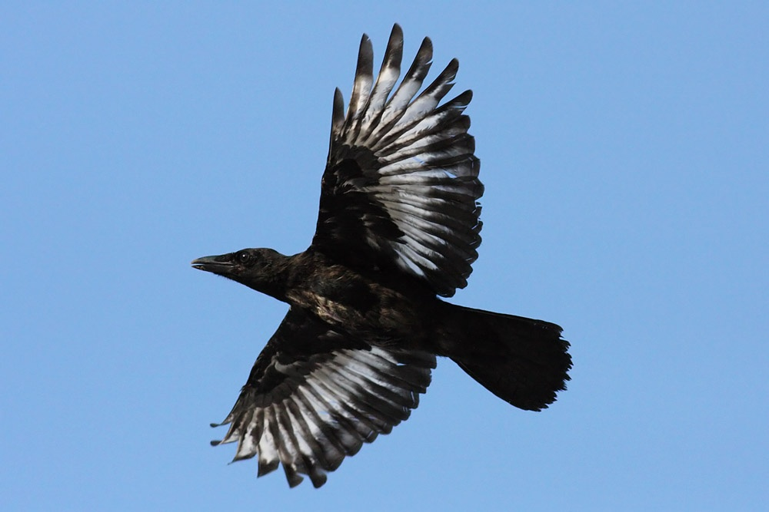
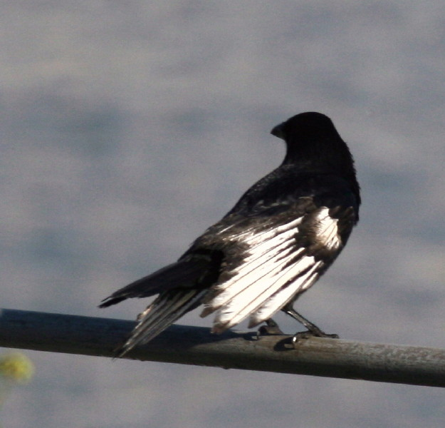

So, what did George see? I am going to take a somewhat circuitous path to George's bird but bear with me. I will get there.

Some time ago (6/25/2012), I wrote about how a combination of the scattering of light with absorption affects the color of a bird, particularly with respect to the greens of parrots and parakeets and the blues of scrub jays. George's bird is, however, a discourse in pigments and I need three pigmented words for this discussion: eumelanin, pheomelanin, and carotenoids. There is a fourth avian pigment, turacoverdin, which is a flamboyant green, but turacos are the only birds who use it and they live in Africa, so I'm going to ignore it and them. The three remaining pigments (and their absence) provide the basic coloring palette for birds. The canvas is white. Take away all pigments and you have a white feather. For some birds, that's as far as it goes. You have the white of a snowy egret, who apparently doesn't care if everybody can see him. In general, however, white makes it easy for a potential predator to pick you out of the canopy, so most birds want to dab the canvas.

Let's start with carotenoids. The carotenoids are blue absorbing (hence generating reds, yellows and oranges) pigments found in algae, among other things, that are used for generating the energy needed to run photosynthesis. Birds make no carotenoids but, if the pigment is present in their food or the food of their food, they can use it to generate a variety of reds, yellows and pinks. Take away the carotenoid laced food and the color goes away with the next molt. Your pink flamingo becomes white; your male house finch loses his orange/red bib and looks a lot like a female. Carotenoids are dietary. There are examples of genetic defects in birds that affect their ability to utilize carotenoids but these are quite rare.

The other two pigments, eumelanin and pheomelanin, are the workhorses of the avian visible light coloring world. Both are derivatives of the amino acid tyrosine. Eumelanin is the source of the grays and dark browns you see in many birds and the black you see in crows. Pheomelanin can produce colors ranging from creamy taupes to light reddish browns (your Irish friend’s red hair is due to unusually high concentrations of pheomelanin). So, that's the setting. In practice, you are a bird who wants some color, so you break down tyrosine and make the desired melanin. If everything works right, you will look like your compatriots with all your plumage colored in the right places. You will be broadcasting fitness to potential mates, while hiding in plain sight from predators. You will be a happy bird.

Unfortunately, whether you are a human or a bird, everything does not always work right. Suppose you have a recessive genetic anomaly that prevents formation of the enzyme tyrosinase, without which you can't break down tyrosine. If you can't break down tyrosine, you can't make melanin. Except where you can use carotenids, your feathers are going to be all white, no matter how brown or black they are supposed to be. A complete lack of melanin means that you are an albino and this is likely to be really bad news. Most albino birds die soon after their parents stop feeding them because albinism in birds (and other vertebrates) is strongly correlated with bad eyesight (making it hard to find food or avoid being eaten), sensitivity to light, poor camouflaging against predators, and poor resistance to disease. In some cases, members of your own species may even attack you as something too different to tolerate. The white bird in the photo on the left is an example of an albino crow [This and adjacent photo are lifted from a 2006 paper by van Grouw (Dutch Birding, volume 28, pages 79-89; you can get a pdf from http://www.housesparrows.eu/englishSpeak.html).]. The photo happens to be one of a carrion crow, which is native to Europe, but the bird, like an American crow, should be all black. This crow can't process tyrosine, so the feathers are unpigmented (i.e., white). Note that the eyes, bill, and legs are pink/red because there are no melanins for this bird (blood vessels and/or carotenoids become the default coloring entities). This is a hallmark of albinism, white feathers where you would expect grays, blacks or browns, and pink/red for eyes, bill, and legs. The second photo, to the right of the carrion crow, shows an albino European finch (yes, another European bird but what can you expect from a Dutch birder). This bird should have extensive brown and black plumage but he doesn't because he can't synthesize any melanins. The point I wanted to make with this photo is that albinism is about the inability to produce melanins, which must be synthesized on site, not an inability to process carotenoids, which are brought into the bird in a ready to go state.

George's bird is not an albino. It can clearly make melanin and George noticed nothing odd about the head or legs. There were just patches of white on some feathers that should have been all black. Generally, if you have a bird with normally colored eyes, bill and legs but white feathers where there should be some other color (generally in patches but occasionally extending to all feathers), it is leucistic. Literature on the cause or causes of leucism is confused at best, perhaps in part because the affected birds are rare and not well studied. The term may also lump many different conditions. Unlike albinos, who have a host of attached demerits for survival, leucistic birds often make it to adulthood. Nevertheless, you may be discriminated against as a leucistic bird, when it comes to breeding, so to the extent leucism reflects a genetic component, you may have some difficulty in spreading it down generation.

George's bird is rare. I have surely seen thousands of crows in my travels but haven't seen one like George's bird. George had not previously seen a leucistic crow. Alan hasn't seen a leucistic crow. Project FeederWatch, which is a program run through Cornell, came up with <1,000 leucistic birds among 5.5 million reported individuals, which means a limit across all North American species of less than 1 in 5,500. Since a leucistic bird is something you would immediately glom onto as strange and worthy of attention, it is likely that the 1 in 5,500 you get from Project FeederWatch significantly overestimates the frequency of occurrence. In penguins, where there has been some serious surveying, leucism is a 1 in 20,000 to 1 in 150,000 type of occurrence, depending on the species. Leucistic crows may be more common in other areas (I saw an estimate of 1 in 1,000 from a bird bander in New York) but they are seriously rare in southern California. George had a once in a lifetime observation. With a little luck, we will all have a once in a lifetime observation.

The date: 7/17/2013
The week number: 29
The walk number: 1204
The weather: 87 F, full sun
The walkers: Alan Cummings, Kent Potter, Vicky Brennan, Viveca Sapin-Areeda, John Beckett, feisty black phoebe
The birds (14):

1 Northern Mockingbird
1 Mourning Dove
5 Anna's Hummingbird
5 Acorn Woodpecker
4 American Crow
2 Black Phoebe
1 Downy Woodpecker
1 Dark-eyed Junco
2 Black-chinned Hummingbird
9 Red-masked Parakeet
7 Bushtit
1 Hummingbird, Selasphorus
3 Lesser Goldfinch
1 Common Raven

--- John Beckett

Respectfully submitted,
Alan Cummings,
7/27/13

