7/10/13

Records come in many forms. They may pattern through a day off from a week of rain, leading to a wild scramble for food. It may be a wild menagerie left in clusters of song and call. It may be a quiet accumulation that surprises. For week 28, the record is 17, set just last year. The number may be less than half of the all-time record of 37 but a day with a record of 17 is just as hard a breech as a 30 bird day. We didn't breech for week 28 but we did skim the surface. The species count started very slowly but we ended with two gifts, a rock pigeon perched on top of Millikan and a swallow of indeterminate species, flying off to the south. These odd fellows brought us to total of 17 species for the walk and a tie with the record for week 28.

See the plots at http://birdwalks.caltech.edu/bird_data/species_time.html and
http://birdwalks.caltech.edu/bird_data/two_plots.htm

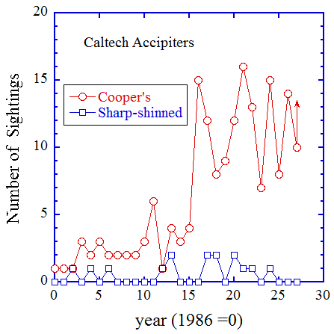
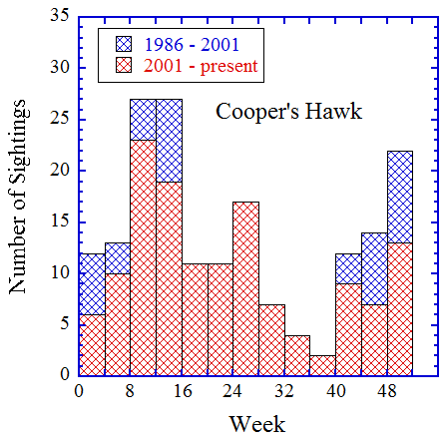
Sometimes, the key to a walk comes at the end. You get a great view of a flicker over the duck pond or see the mallard you missed on the way out. You encounter the bird(s) needed to meet or exceed the reigning record. Records are usually made with late birds and no worms and this week was no exception. The pigeon brought us a view of the promised land and we tied the record with a swallow species. Now, an ambiguous swallow is a difficult wrap but the rock pigeon would have to be regarded as a late walk candidate for bird of the week, except that it isn't because some walks, this walk, are best in the beginning. It doesn't matter how the rest of the walk flows. It doesn't matter who is perched on top of Millikan. We are a basking glow of the beginning.

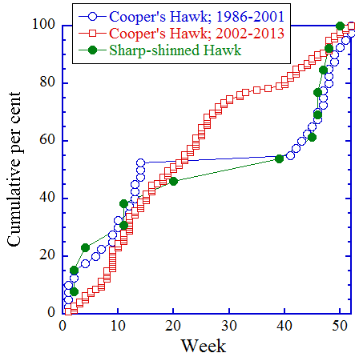
The highlight of our walk came in the first few minutes. Due to the Maintenance Yard being taken over by the Child Care Center construction, the walk route was changed so that we now walk down to Arden and then post in front of the Health Care Center. This has been a very productive spot for us but today it is avian silence with the look of a very bad day but cause sometimes comes when it wants to and there is a localization of the bad birding. An adult Cooper's hawk flies across Arden towards campus. She, and I say this based primarily on size, disappears into trees behind the Health Center. Moments later, a second hawk flies across the street. This bird is clearly a juvenile, based on the strong vertical striping lining the body. It lands, somewhat awkwardly, in a tree in front of the Health Center. We are barely absorbing this event, when a third bird, flying more deliberately but at a lower level than the other two, flies past us. We didn't see this bird land and I only saw the back clearly, which was brown, making it indeterminate (faded adult female or, much more likely, another juvenile). We had three close Cooper's in about a minute! This had to be some kind of record. It appears that we intersected a training mission for a pair of recently fledged Cooper's hawks and they gave us our tenth sighting of the year. From the first figure (left), ten sightings is within the range established over the last decade for Caltech Cooper's hawk sightings in a calendar year (I'll come back to the sharp-shinned hawks later), but far higher than what we were seeing prior to 2002. The reason for this paradigm shift can be seen in the second figure and it beards the tale of two birds. Cooper's hawks winter in the San Gabriel Valley and migrate to northern California and points north in the spring. They are generally all gone by mid April and this shows in the blue hachured pattern of the histogram figure on the right. There is nothing between weeks 14 and 41 prior to 2002. At some point in the last couple of decades, at least two birds noticed that large numbers of prey birds were staying home. “Why fly all the way to Oregon to breed,” they think, “if we can do that in the comfort of your own winter territory?” So, an enterprising pair of hawks takes a chance and stays here to breed. A few more took a chance and, eventually, they were taking chances in the vicinity of Caltech. We now have a viable breeding population of Cooper's hawks in the general vicinity of the campus and this is leading to more sightings overall and, particularly, more sightings in the late spring and early summer. You can also see this effect in a cumulative percent plot. Prior to 2002 (open blue circles in the figure), we saw about half of our calendar year sightings of Cooper's hawks before week 15, about half after week 40 with none in between, a discontinuous distribution. After 2001 (open red squares), you get a continuous distribution with an early summer bulge associated with breeding and post-fledge training. The sightings drop off into the deep summer (the cumulative per cent flattens between weeks 30 and 40) because the locally breeding birds head uphill, although we can now get a Cooper's in any week of the year. The cumulative percent plot suggests that we have seen 71% of the weeks with Coopers by week 28, which leads me to the fearless Fosdick prediction that we will have four more Cooper's sightings by the end of this year and a final tally of 14 ([10 sightings so far this year]/0.71 = 14), the same as 2012.

Up to this point, I concentrated on Cooper's hawks for the obvious reason that this is what we saw. However, we have two accipiter species in southern California, Cooper's hawks and sharp-shinned hawks, and I would be remiss in not connecting them. In the first figure, it is apparent that we don't see a lot of sharp-shinned hawks and we have claimed none since week 20 of 2008. The cumulative distribution with time suggests a pattern very similar to that of Cooper's hawks prior to 2002, a species that migrates past us in the spring and fall with overwintering and small numbers. The cumulative percent plot shows essentially the same characteristics as pre-2002 Cooper's hawks and, if that week 20 bird from 2008 was a misdiagnosed Cooper's, it would be even more similar. If sharp-shinned hawks are breeding in the San Gabriel Valley, they aren't doing it near Caltech.

The date: 7/10/2013
The week number: 28
The walk number: 1203
The weather: 82°F, sunny
The walkers: John Beckett, Kent Potter, Viveca Sapin-Areeda
The birds (17):

1 Rock Pigeon
1 Northern Mockingbird
8 Mourning Dove
5 Anna's Hummingbird
9 American Crow
3 Cooper's Hawk
20 Red-masked Parakeet
5 Black Phoebe
1 Yellow-chevroned Parakeet
1 Red-whiskered Bulbul
3 Hummingbird, Selasphorus
1 Black-chinned Hummingbird
1 Common Raven
10 Bushtit
1 California Towhee
3 Lesser Goldfinch
1 Swallow, Species

--- John Beckett

Respectfully submitted,
Alan Cummings,
7/25/13

