7/3/13

You might think that the absence of Alan translates into low species totals. You are after all, depriving the group of two eyes and one strong birder. However, the opposite seems to pertain and the key is time. Alanless walks tend to be a bit longer than Alanated walks and this appears to be just enough yield the odd bird and the odd bird can be the difference between a record and an also ran. This week, we ran without Alan and tied the record of 18, which was originally set in 2009, matched in 2010, and now matched again in 2013. In the end, we were well above the median of 12 and in no danger of lurking near the record low of 8, although I must admit that I was worried about which end of the scale we were going to be up on as we exited Tournament Park. Fortunately, birds kept dribbling in and we slowly drifted into the stratosphere.

See the plots at http://birdwalks.caltech.edu/bird_data/species_time.html and
http://birdwalks.caltech.edu/bird_data/two_plots.htm

Before discussing the bird of the week, I wanted to mention something I neglected to bring up in last week's report. Juvenile acorn woodpeckers look like adult females. So, although the red on white rule is definitive for a male, red on black could mean an adult female or a juvenile. This feature actually caused trouble in early studies of this species. The "observation" was that there were a lot more female acorn woodpeckers than males and this led to some tortured attempts to explain the imbalance. The actual sex ratio is roughly one-to-one.

From a purely statistical perspective, the highlight sighting of the day had to be the turkey vulture (yes, of course, via Viveca). It was a solid view, a normal view. The bird was an easy capture but not especially close. We had no rising oohs and ahs over a fleshy pink head and white bill. The curiosity lay in the timing. We get very few turkey vulture sightings in the summer and there has never been a Caltech bird walk vulture in July, until now.
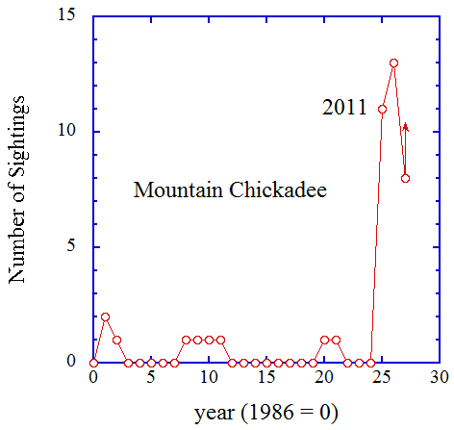
The highlight bird arose from a not quite right sound across the street from Morrisroe. Vicky and Viveca are drawn like bees to a clover field. The calls are strange but clearly reminiscent of chickadees. It could be the great junco conundrum of Prufrock's tree all over again. Then, we had an odd song and a weird looking bird due to odd lighting. Here, we have Indian hawthorns lining a corner wall shaking. Finally, a bird ventures near the surface. What we can see is visually consistent with being a chickadee. It's not a very good look but I put down one mountain chickadee (see photo at the end of the report for what a great look at a mountain chickadee might be like). We spend a few more minutes trying for something more definitive for Jane and Roy to see but we have to give it up. Viveca and Vicky stay for an extended attempt at characterization, while the rest of us saunter up Wilson. They catch up to us before we get to California and report that there are at least two chickadees involved. The odd calls were almost certainly the signature of juveniles who had fledged but were not yet strong enough fliers to accompany their parents on extended foraging trips. This led to being parked in the hawthorns and told to not draw attention. As with human teenagers, the admonition game didn't work very well.
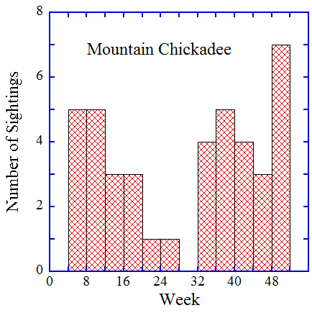
We now have eight chickadee sightings for the year (see first figure) and this continues a sharp spike started in 2011, when we went from being lucky to see one chickadee in any given calendar year to having nearly a dozen chickadee weeks, some with several chickadees. The first chickadee sighting of 2011 was in August when you would expect juvenile dispersal to be in high gear. It seems likely that we were on the receiving end of an irruption in the fall of 2010 (Station fire related?) that led to a chickadee range expansion extending all the way to Caltech. So far, it appears to have worked out for them, as the species now appears to be breeding in our general vicinity. This week, we apparently blundered into a nursery. Later in the summer, this year's juveniles will disperse and we will have an opportunity to see some more of them, probably with adult quality calls.

In other important news, binocularize appears to be holding on and gathering adherents.

The date: 7/3/2013
The week number: 27
The walk number: 1202
The weather: 83 F, partly cloudy to mostly sunny
The walkers: John Beckett, Viveca Sapin-Areeda, Vicky Brennan, Roy Williams, Jane Williams
The birds (18):

1 Northern Mockingbird
1 House Sparrow
2 Mourning Dove
3 House Finch
3 Anna's Hummingbird
2 Acorn Woodpecker
5 American Crow
10 Bushtit
4 Black Phoebe
1 Nuttall’s Woodpecker
5 Lesser Goldfinch
4 Hummingbird, Selasphorus
2 Black-chinned Hummingbird
3 Red-masked Parakeet
3 Mountain chickadee
1 Turkey Vulture
10 Yellow-chevroned Parakeet
4 White-throated swift

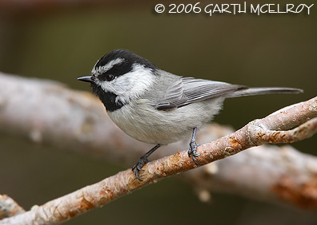
http://www.featheredfotos.com/Species%20Pages/Songbirds/mountain%20chickadee.html

--- John Beckett

Respectfully submitted,
Alan Cummings,
7/24/13

