6/5/13

It was sunny and 72°F. Chances of rain were nil but, if you were on the bird walk, your chances of intersecting somebody from India were excellent. Ashish and Mithilesh were with us again and they were joined by Nishank Jain, another product of Ashish's recruiting efforts, and the 140th walker on the Caltech bird walk. It was also a fairly good walk for a week 23. We saw 21 different species. This was well below the 27 we saw last year but it is only the second time that a week 23 walk has broken the 20 bird barrier (i.e., if it hadn't been for a crazy good walk last year, this would have been the record). Naturally, we were well above the median of 14 and record low of 11. It's hard to argue that this was not a numerically successful walk.

See the plots at http://birdwalks.caltech.edu/bird_data/species_time.html and
http://birdwalks.caltech.edu/bird_data/two_plots.htm

Bushtit flocks still exist but they are considerably smaller than they were earlier in the year. It's not the hawks. It's the romance. Bits of Caltech bushtit flocks have been breaking off in twos (mated pair) and threes (mated pair plus a male helper) to form small families. On this walk, we saw at least five bushtits near the corner of California and Arden, probably part of a flock and two near the red door, probably a pair. We also got a very nice view of a California towhee in Avery garden. He first flushed Alan, flew over to a bench to keep an eye on him from a couple meters away for a minute or so and, then flew across the garden to a compost pile, which appeared to have a newly hatched collection of midges, free for the scooping. It was probably a pretty good day for the towhee.
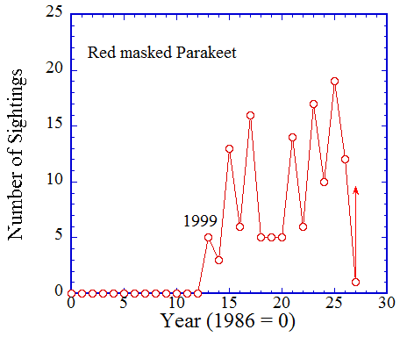
The towhee was nice encounter but the highlight has to be the red-masked parakeets, although they only gave us a squadron flight of eight passing over Arden as they coasted in for a landing in the trees next to the tennis courts. They were heard before they were seen but they were seen and heard quite well. Alan showed no interest in chasing them for confirmation. We might have seen more of them in close proximity had we used the old walk route, which would have taken us along the tennis courts, but we abandoned this leg of the walk when construction began on the new child care center. We have partially compensated for the loss of the Maintenance yard and path along the tennis courts with a short jaunt to Arden and the health center and, I think, overall, this has been a positive change to the route. It certainly beats trying to coax sightings out of surreptitious peeks into the eviscerated remnants of the Maintenance yard taken from outside the lot, even if there is the odd parakeet to be seen along the way and the odd tree top bird viewable from the entrance.

Red masked parakeets have become a signature of summer for us. We rarely see them before week 22 but they are fairly common captures between now and week 37 or so, just in time for a change of the guard to birds who are actually on migration. It's the kind of pattern you might expect of a species arriving from elsewhere for the summer breeding season in downtown Pasadena, except that it isn't. Our red-masked parakeets live in the San Gabriel Valley year round but they move from area to area to take advantage of ripening food sources, whether they be berries or flowers (i.e., if you want to see a red masked parakeet out of season for Caltech, check the latest e-bird offerings and drive, bike, or even walk to one; if you want a reliable off-season northern rough winged swallow, you will want to polish up your passport).

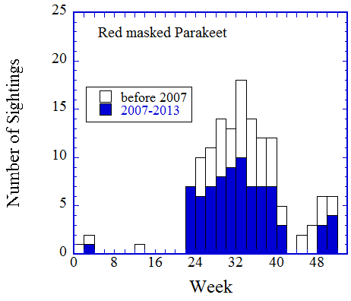
Caltech is on the lunchtime menu in the summer for red masked parakeet but this is a recent phenomenon. The first sighting of a red masked parakeet on the Caltech bird walk didn't happen until 1999, perhaps not surprising, given that there were only a couple dozen red-masked parakeets in the entire San Gabriel Valley as late as 1997. Since then, there is a general sense of increasing sightings frequency with time, although in a saw tooth pattern. There is a break in this pattern between 2004 and 2006 but there doesn't appear to be any obvious change in the basic pattern of summer visitations (second figure) before and after 2007. Perhaps, there are modest changes in the quality of forage that lead to parakeets, in some years, arriving on campus in the morning before the walk or later in the afternoon after we have gone back to work. If their schedule doesn't mesh with ours, we won't see/hear them. We will have what appears to be a bad year for parakeets when we are actually confronting an incompatibility in scheduling.

The photo, which has a dynamic composition that takes full advantage of the lines and colors of the bird, was taken by Debi Tuttle on June 4 in Grant Park, just north of campus. There's a fairly decent chance that the flight of eight we saw the following day included this bird. From an identification perspective, the principle competition is the mitered parakeet. For a comparison, I include a second photo, which was lifted from
http://www.oiseaux.net/photos/hans.spiecker/mitred.parakeet.1.html
From Debi's photo, you can see that the solid patch of red on the head of the red-masked parakeet masses beyond the eye and down to the bill. In a mitered parakeet, there may well be red surrounding the eye but it is a busy shredding into green. A second important feature is that the red masked parakeet has a shoulder patch that usually visible when perched, at least in adults, and readily apparent in flight. A mitered parakeet doesn't have a red shoulder patch.

A basic resource for the exploration of established feral populations of parrots and parakeets in southern California is the California parrot project at http://californiaparrotproject.org/id_guide.html

The date: 6/5/2013
The week number: 23
The walk number: 1198
The weather: 72 F, sunny
The walkers: Alan Cummings, Vicky Brennan, Mithilesh Mishra, Viveca Sapin-Areeda, Carole Worra, John Beckett, Nishank Jain, Ashish Mahabal
The birds (21):

1 Scrub Jay
1 Northern Mockingbird
6 House Sparrow
2 Mourning Dove
9 House Finch
5 Anna's Hummingbird
1 Acorn Woodpecker
3 American Crow
2 Mallard
3 White-throated Swift
2 European Starling
1 Cooper’s Hawk
7 Bushtit
4 Lesser Goldfinch
1 Nuttall’s Woodpecker
8 Red-masked Parakeet
2 Black Phoebe
1 Hummingbird, Selasphorus
1 Band-tailed Pigeon
2 Common Raven
1 California Towhee
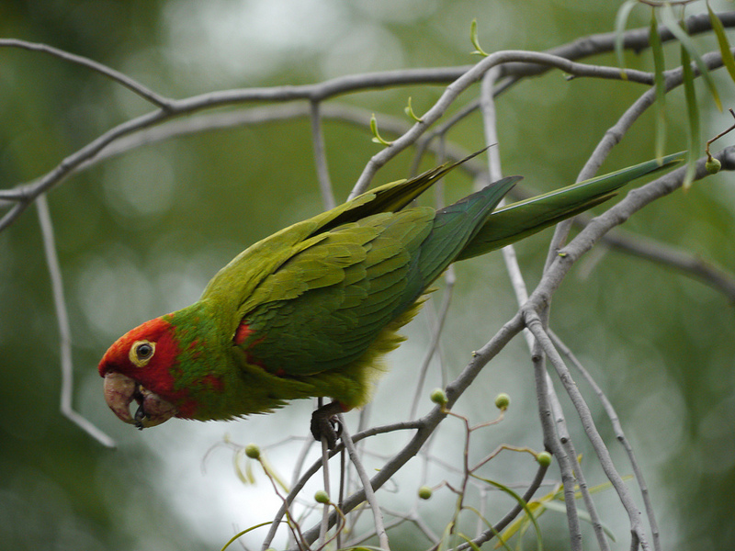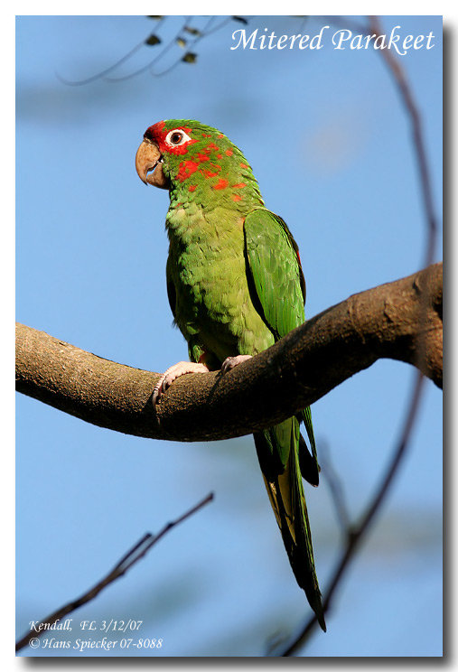

--- John Beckett

Respectfully submitted,
Alan Cummings,
6/18/13

