5/29/13

We had a new walker (# 139), Mithilesh Mishra. Mithilesh, who is visiting with Ashish and will be here for a couple of weeks. He is clearly making the most of his opportunity as the most extravagantly attention grabbing new walker of my experience (keeping in mind that I have only met two dozen new walkers). Mithilesh brought an SLR with a huge wide angle lens mounted on a tripod. He would be a Joe Schmo at Bolsa Chica but, on campus, he becomes an oddity that motivated several people to wander over to find out what we were up to. Clearly, the group needs to invest in a spotting scope so we can cart it around with us as an advertizing totem.

We did manage to see a few birds. We dipped below 20 but our species count of 19 was still mid way between the median (15) and record high (24) for week 22.

See the plots at http://birdwalks.caltech.edu/bird_data/species_time.html and
http://birdwalks.caltech.edu/bird_data/two_plots.htm
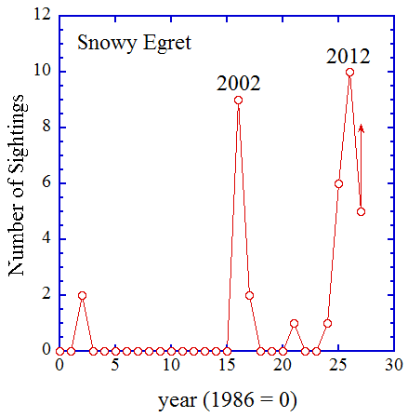
This week, there are no pretenders to the throne. I could certainly find a bird to discuss and even get excited about but this is completely unnecessary. The highlight bird is a snowy egret. He was flying north, more or less parallel to Wilson. It was not a terrifically close look but we could clearly see the black beak and yellow feet. He flies towards the north end of campus and then turns east and passes out of our line of sight. We were hoping that he might decide to stop at one of our campus supermarkets (aka ponds) but we didn't see him again.

Snowy egret visitations on campus are sporadic and, probably, tied to a small number of individuals. There was a cluster of sightings around 2002 and another, peaking (probably) in 2012. Usually, a snowy egret sighting reflects a single bird but we occasionally get pairs and, once, I saw three birds, all perched in a tree overlooking the lower Throop pond. Sometimes, a snowy will stay until he has fished out the local ponds, a process that can take as long as four or five weeks but is usually more like two or three.

Last year was the biggest snowy egret year ever with ten sightings. This year, we have five snowy egret sightings so far, but we probably won't see another until December, if then (see second figure). Of course, I would have said the same thing in the middle of this week's walk, just before our bird of the week gave us a fly by. From the second figure, snowy egrets are wet season birds for us as are great egrets. Getting a snowy in week 22 was a big surprise.

This brings me to the question of the week: what is the difference between an egret and a heron? The basic biological answer is that egret starts with an "e" and heron starts with an "h". All egrets are herons. So, what makes a heron an egret? If you have nice plumes that a late Victorian lady of good breeding wanted to have in her hat, you were an egret and you were likely to be shot during the breeding season. If you had third rate feathers, perhaps usable for background and ballast but not for prominent display, you were a heron.
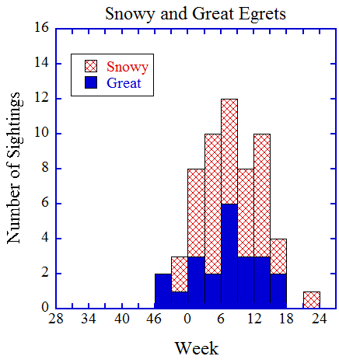
Since we caught a snowy and there seemed to be some initial confusion over what kind of egret it was, it seems appropriate to take a moment to compare white feathered egrets from an identification perspective. There are three egrets on the Caltech bird list (snowy, great and cattle). Now, members of the snicker audience are probably thinking that a juvenile little blue heron should be included in this panel, even though we have yet to see one on campus, but that is just not going to happen here. Let's get real. If there were a juvenile little blue heron on campus, the birding paparazzi would be all over it. You would see dozens of people wandering around campus with their tripods, spotting scopes and mega lenses. Little blue herons can be found in some numbers in lower California and along the Gulf coast but they are fairly rare in the state of California, although I did see one at Bolsa Chica a couple of years ago. Even more stringent arguments can be made over the possible inclusion of white morphs of the great blue heron. If we were in Florida, we would have to worry about them but not on our turf. Frankly, we can almost dismiss cattle egrets, too. They are common regionally, mostly associated with agricultural areas, but we have had all of two cattle egret sightings on the bird walk and those came on successive weeks (51 and 52) in 1992. That's almost certainly just one bird in over a thousand walks. Alan may remember the particulars but those sightings were long before my arrival on the bird walk. So, we haven't seen a cattle egret on campus in more than twenty years but I will retain the species in this discussion, just for the sake of completeness. Below the bird list for the week, I have six photos with one standing and one flying bird for each of the three egrets, posed in the order snowy, great, and cattle. Let's suppose that these three birds are your only options. Look at the beak. A completely black beak means a snowy. Cattle and great egrets have yellow beaks (a cattle egret beak can get rather orangey during the breeding season but that bird is also going to have a lot of brown and no black beak). Bright yellow feet are unambiguous indicators of a snowy egret. A negative foot inspection doesn't work reliably because a bit of mud can turn a yellow foot into an apparently black one but, if you see those yellow feet (or a yellow to green stripe on the back of the leg), you are done. Both cattle egrets and great egrets have yellow bills but the great egret's bill is noticeably longer relative to the head. Another feature in the standing birds is that they all have long sinuous necks but the neck of a cattle egret is very compact relative to either a snowy or a great egret. This is readily appreciated on the ground but it also affects the silhouette in flight. There is a lot more neck to curl up in a great egret than there is in a cattle egret. From the in-flight photos below, you can see a decided bulge below the level of the body for the great egret. The same will be true, though much less pronounced, in a snowy. In a cattle egret, the neck will bulge towards the front but the base of the tucked in neck is pretty much in-line with the rest of the body. Also note that both the snowy and great egrets will appear rather leggy in flight relative to a cattle egret. If there is a lot of leg sticking out the back, it's probably not a cattle egret.

The date: 5/29/2013
The week number: 22
The walk number: 1197
The weather: 77 F, sunny
The walkers: Alan Cummings, Mithilesh Mishra, John Beckett, Kent Potter, Viveca Sapin-Areeda, Ashish Mahabal, Vicky Brennan
The birds (19):

2 House Sparrow
5 Mourning Dove
2 House Finch
3 Anna's Hummingbird
3 Acorn Woodpecker
4 American Crow
2 European Starling
1 Mallard
4 Common Raven
1 California Towhee
3 Black Phoebe
1 Cooper’s Hawk
3 House Wren
1 Dark-eyed Junco
3 Bushtit
1 Hummingbird, Selasphorus
1 Snowy Egret
4 Lesser Goldfinch
7 White-throated Swift
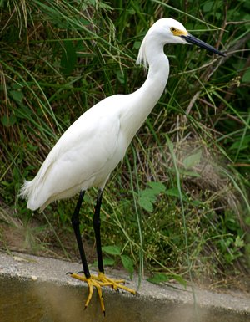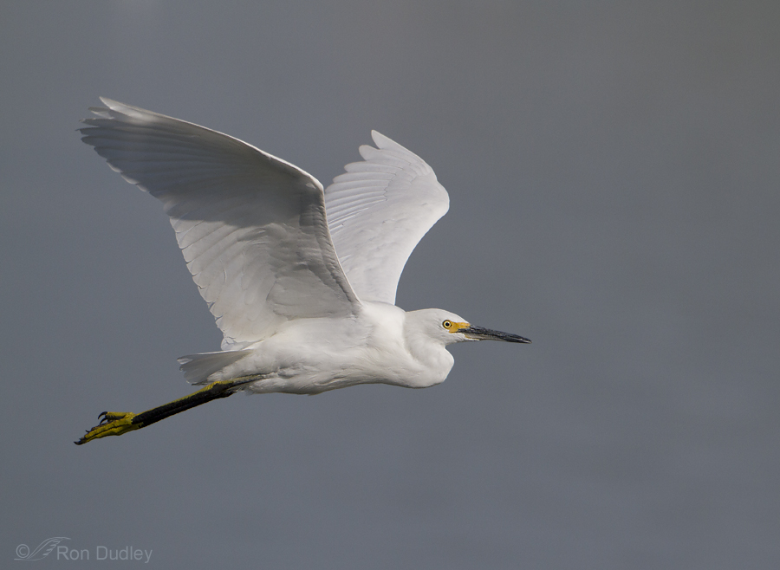
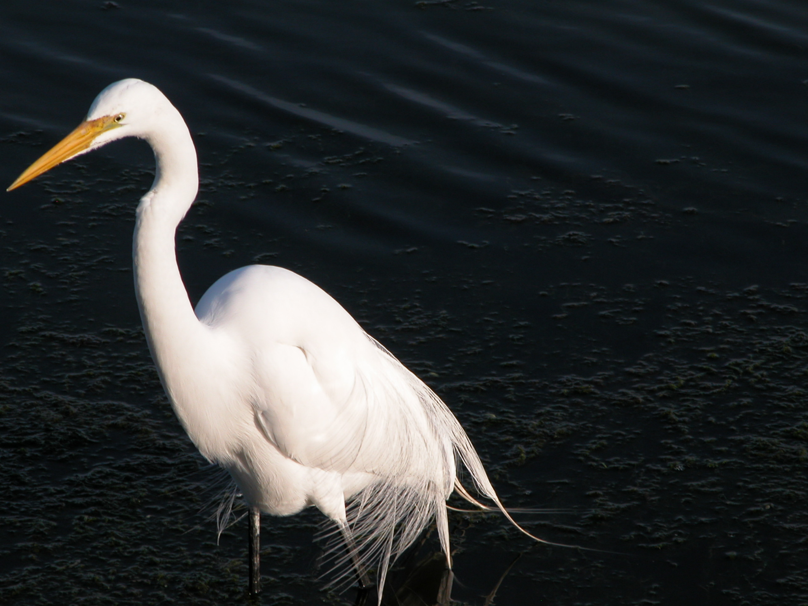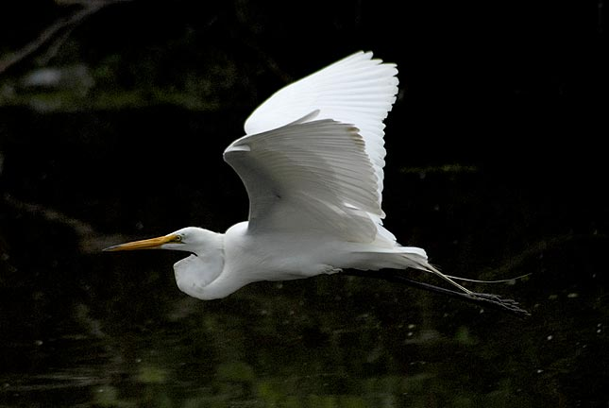
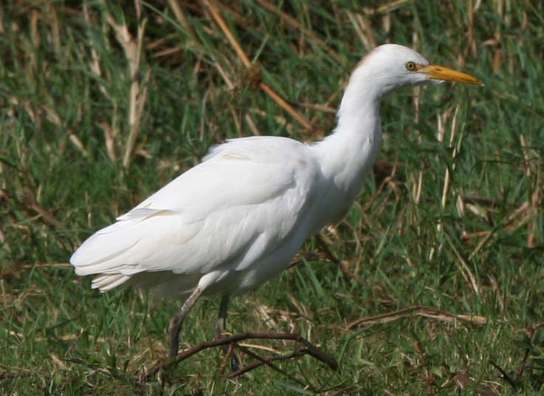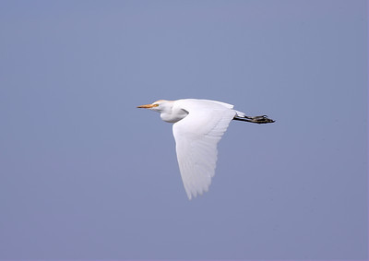
The standing snowy egret is from http://www.assateague.com/sn-egret.html (i.e., this is an east coast bird). The photo of a snowy egret in flight is by Rob Dudley and was taken from http://featheredphotography.com/blog/2013/05/12/a-mothers-day-tribute-to-two-women-who-saved-many-of-our-birds/

The standing great egret photos is one I took some time ago at Bolsa Chica and the bird in flight is a Texas bird from http://www.jrcompton.com/photos/The_Birds/herons/Herons-v-egrets.html

The standing cattle egret is from an interesting little site that specializes in bird stamps: http://www.sabirdstamps.com/Individual%20Birds/C020.0320.htm
and the flying bird is from
http://www.lonewolfephotos.com/Other/San-Jacinto-Wildlife-Area-CA/7792988_Sxzhcv#!i=1744611253&k=8tX2ZhQ

--- John Beckett

Respectfully submitted,
Alan Cummings,
6/17/13

