5/22/13

After a walk, Alan scans in the bird list for the day and ships it over to me. I generate a WORD file from the pdf and ship this “Latest_list” back to Alan, who posts it. Vicky then enters our data into e-Bird. It’s like a little cottage industry. Now, usually, I will print out a copy of Alan’s list and scribble notes on it. These may highlight potential birds of the week and the circumstances of their capture. The conversational flotsam drifts can drift to paper and it gifts me keys to at least some of the flavor of a walk. I can resurrect special moments and bring a focus to the report even if the report is written many weeks later (mea culpa). Over the last couple of months, I have been buried with work at the distressing level of not even having enough time to dash off the odd report. Over the last couple of weeks, I have been catching up, although I still have a ways to go. It is all fairly straightforward, if I have my notes. For this week, I have no notes. Maybe, I was getting a little desperate about how far behind I was on report writing. I don't know but the net result is no net and little recollection of the walk beyond recalling a statement of Ashish’s that he had some visitors coming and that some fraction of them would likely be coming on the walk over the next few weeks.

So, absent the sinew, I diverge to the skeleton. We encountered 22 different species, which is a fairly typical result as defined by the post Station fire years (21, 24, 23, and, now, 22). We were, however, well below the record of 26 species recorded in 2009. You might think that this is another Station fire effect but it’s not. The Station fire didn't start until July of 2009 (i.e., after week 21). So, the skeletal result is that we couldn’t dream of touching the sky but we did manage to fly above the median (16) and well above record low (11, set in 1992).

See the plots at http://birdwalks.caltech.edu/bird_data/species_time.html and
http://birdwalks.caltech.edu/bird_data/two_plots.htm
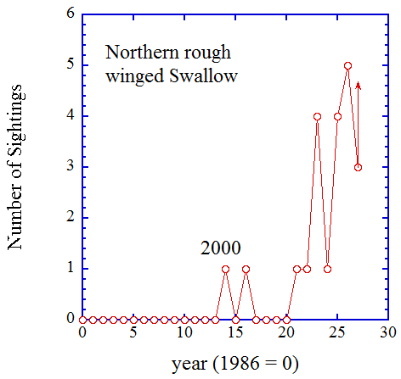
It looks like our geese are gone and there are no dark eyed juncos. Apparently, once the junco juveniles were thoroughly fledged and mobile, it was time to abandon the homestead. The juncos may be gone but we did see a lot of black phoebes, a testament to juveniles establishing new territories relatively close to their natal homes. We had both mallards in the pond but the geese disappeared after one unusually hot day. I was very sorry to see them go as I think the Caltech community had been bonding nicely with the three amigos.

Having disposed of my noteless and, therefore, anemic anecdotal reservoir, I thought it would still be worth while to discuss northern rough winged swallows, as there is likely to be a drop off in sightings potential over the next few weeks. The species is a relatively late acquisition to the bird walk, with no sightings at all prior to 2000 and, if you look at the number of sightings on the bird walk as a function of time, you can also see a striking increase in frequency since 2007. Are we a little more buggy than we used to be? I rather doubt it. The pattern suggests that we are getting the odd breeding pair in the Pasadena area, that spends some time foraging on campus. My expectation is that the nesting sites are off campus, although this is based on the relatively weak pillars of a sporadic sighting frequency and the absence of juveniles. Juveniles get tuckered easily and are, therefore, more sessile than their parents but the parents will fly over to them for feeding or to encourage flight. I’ve yet to see a juvenile on campus, whereas, I see them every year in Sierra Madre (there is a small colony centered in the city spreading grounds for aquifer recharge (they like to rest on the power lines along Grand View, if you are interested). The second figure tells us that there is no winter presence for northern rough winged swallows at Caltech. Some of them winter as far north as San Diego but it is Mexico and Central America for most of them. We see, probably, migration birds passing through campus in the spring and again in mid-summer, as they return south. The pulse of sightings between weeks 18 and 22 is likely due to locally breeding birds foraging on campus.

To answer an obvious but, perhaps unspoken, question: Yes, there is a southern rough winged swallow (found in Panama and points south) but this is not something of concern for identifying northern rough winged swallows in California. Southern rough winged swallows just don't come anywhere near us at any time. If you want to see one, you will need to pack.
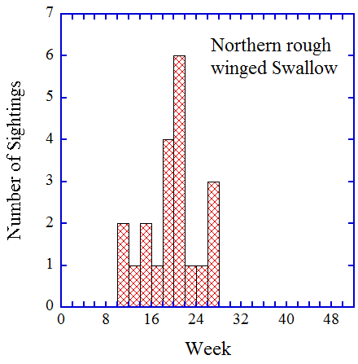
As a general matter, northern rough winged swallows are secondary burrow nesters (i.e., not hole nesters), using sites abandoned by the original excavators (those of bank swallows and kingfishers are popular) but they will also happily utilize pipes and crevices. They are semi-communal in the sense that they often hang out with bank swallows but this is a strictly nonsocial predilection. Northern rough winged swallows like bank swallow colonies because bank swallows tend to excavate more nests than they use and northern rough wings need ready-made holes to breed in because they don’t make their own holes. Since northern rough wings only take possession of abandoned properties, the relationship works. Bank swallows ignore northern rough winged swallows and vice versa (there are exceptions but these are rare). Do we want a swallow colony on campus? Try some garden sculpture. The ideal burrow for a northern rough winged swallow is an abandoned bank swallow burrow. So, you don’t have a sand cliff? Artistically emulate one. Take a pipe with a 10 cm internal diameter, 100 cm long and pose it ~3 meters off of and parallel to the ground. An encasement may or may not be needed. There probably needs to be a top to prevent a potential predator from gaining access, to reduce heating and to complement the aesthetics. With a little thought and a little more talent, you have the basis for a serious work of modern art (think Pompidou Centre) but with a strong naturalistic interplay.

Given the rather elegant flying style of a northern rough winged swallow, you might reasonably anthropomorphize a romantic love life. This would, however, belie the reality. A breeding pair of northern rough winged swallows basically consists of two birds of opposite sex, who decide that they both like a particular burrow and can sort of tolerate each other. What's love got to do with it?

The photo is one of northern rough wing swallows that I took several years ago next to a bridge near the Muth Interpretive Center at Upper Newport Bay. This is a generally good spot for northern rough wings but, when I was there a couple of weeks ago, it was all cliff swallows fluttering around under the bridge. As geologists like to say, the only constant is change.

The date: 5/22/2013
The week number: 21
The walk number: 1196
The weather: 71 F, partly cloudy
The walkers: Alan Cummings, Ashish Mahabal,
Kent Potter, Viveca Sapin-Areeda, John Beckett
The birds (22):

1 Rock Pigeon
1 Scrub Jay
2 Northern Mockingbird
5 House Sparrow
10 Mourning Dove
1 House Finch
3 Anna's Hummingbird
5 American Crow
6 White-throated Swift
2 Common Raven
3 European Starling
2 Lesser Goldfinch
2 Mallard
8 Black Phoebe
1 Nuttall’s Woodpecker
1 Northern rough-winged Swallow
3 House Wren
1 Downy Woodpecker
1 Red-tailed Hawk
1 Yellow-chevroned Parakeet
1 Hawk, species (accipiter)
1 Bushtit

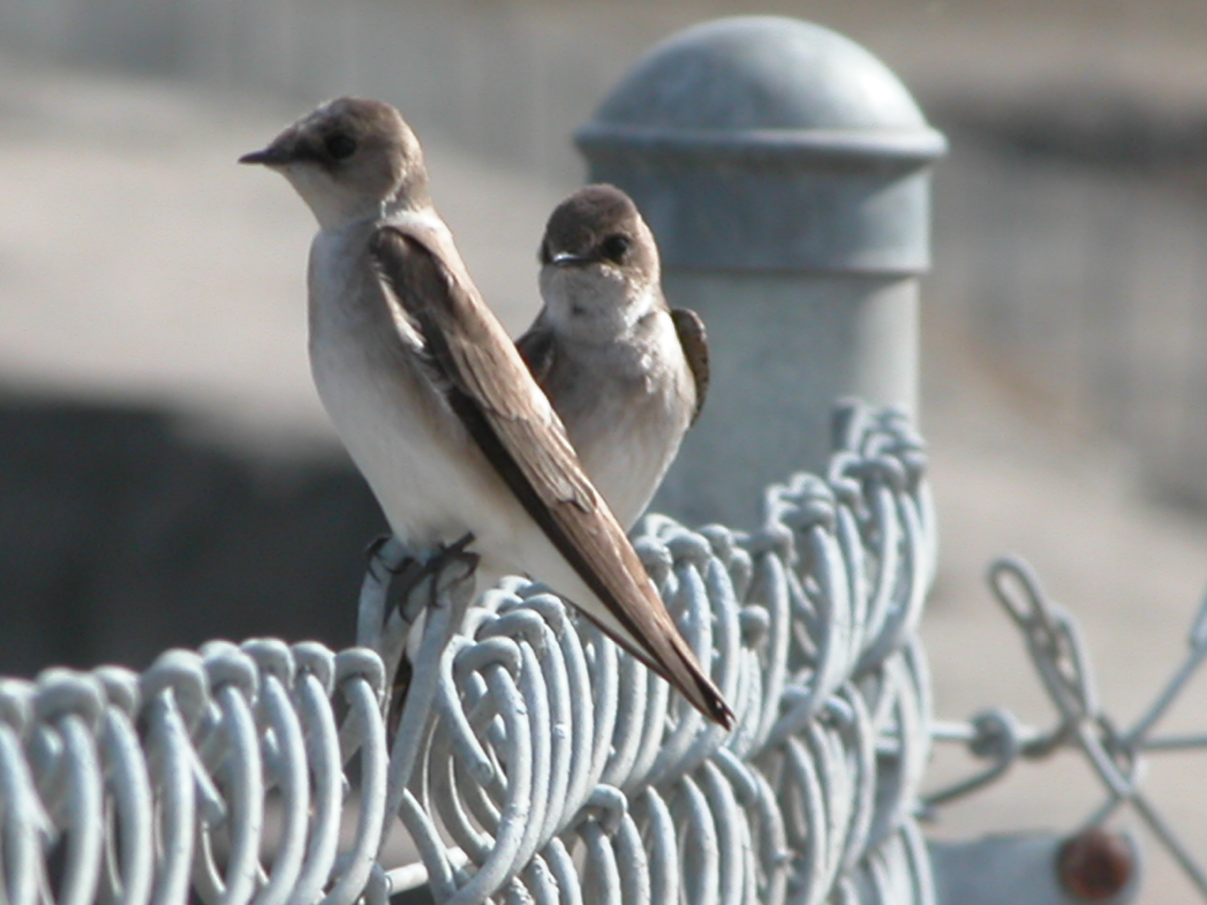

--- John Beckett

Respectfully submitted,
Alan Cummings,
6/14/13

