5/1/13

Sometimes, a walk is odd. It may flow like a sluicing river running from boulder to boulder, as you hop above, or ooze like the old mud of a peneplain. The birds may be normally distributed. There may be nothing odd to focus on but there is some sentient sliver of the experience that creases just beyond articulation. It is not odd on the obvious merits but you know it to be odd. This was one of those strange walks where you think things are a bit dull but, somehow, bird-by-bird you end up with an impressive total. We acquired 24 species, which is quite good for a week 18 walk. We were just shy of the record 25 set last year, well ahead of the median of 18, and nearly double the record low of 13.

See the plots at http://birdwalks.caltech.edu/bird_data/species_time.html and
http://birdwalks.caltech.edu/bird_data/two_plots.htm
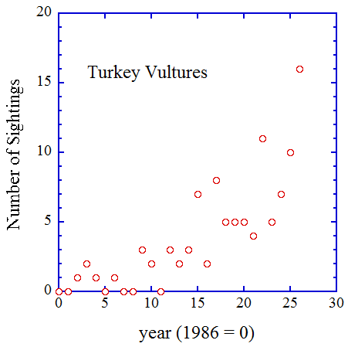
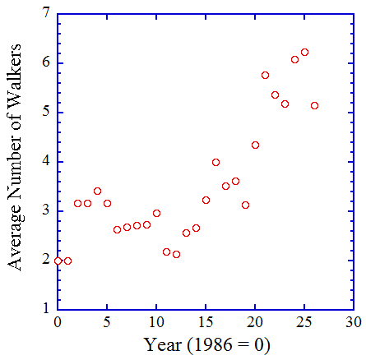
A new list bird is an exciting matter of taste and we always have a taste for new species. We had one last year (Alan’s red lored parrot). We've already had one this year (Ashish's oak titmouse from last month). I thought we might have one this week, except for a couple of intruding issues. We are at the running track and we see a swallow with what appeared to be a dark ruddy breast. I thought it was a barn swallow but was I being fooled by bad lighting? It certainly wasn't a northern rough-winged swallow and I think I saw enough unremarkable rump to say that it wasn't a cliff swallow. In the end, however, we had to concede too much distance. The bird was on the other side of the field, leading to multiple opinions and, when there are multiple opinions, it becomes a consensus call. The lowest common denominator was swallow species and that's where we left it (as in not northern rough-winged). So, one big issue is that we couldn't confidently assign the species. What was the other issue? We have the unruly fact that we have previously recorded barn swallows on the walk, first in 2006 and, most recently, in 2010. Still, a barn swallow would have been an easy bird of the week. Almost always, one can hope.

From a purely highlighting perspective, the first black-chinned hummingbird of the season deserves mention. This bird was a male high up in the canopy near the red door, pondering territory potential. "Do I stay here and try to attract a mate from among the females, who will be passing through campus in a week or two or do I move further north?" He will probably keep going but black-chinned hummingbirds do breed in the San Gabriel Valley. Last year, we had a female nesting outside Human Resources. She came with the first blushing bloom of agapanthus. Perhaps she will be back but that is a story for telling in another month.

Mockingbirds can mimic the sounds of other birds with varying degrees of authenticity and you can be misled by them, both because you are fooled into thinking that it is the bird he is emulating and because you hear something else and, being the canny birder that you are, you dismiss it as a mockingbird when it isn't. I once walked towards a cactus wren but, when I rounded the corner that would bring him into view, I was confronted with a mockingbird doing a cactus wren imitation. I was fooled not just because it was a very good rendition, which it was, but also because the mockingbird didn't change songs after a few repetitions. This bird was, I suspect, working with a new and strange song, leading to far more repetitions than normal. So, having heard the Avery mockingbird do a red-shouldered hawk call, we are primed against a red-shouldered hawk. Naturally, as we continue the walk down Holliston, we hear a red-shouldered hawk. Surely this is just the mockingbird mocking us. However, the calls continue and we eventually land on the correct identification. Fortunately for us, red-shouldered hawks are very talkative and they always sound like red-shouldered hawks. A visual follows just in case there are any lingering doubts.

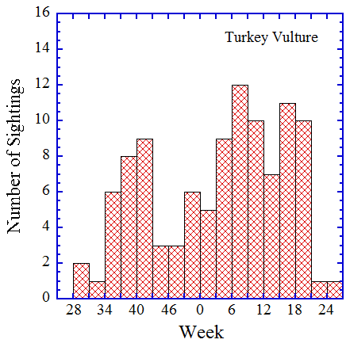
For a data bird, I thought it time to consider the clergy. In this region, a turkey vulture, or two or three, delivers the last avian rites for most mammals and many larger birds. If there are a lot of dead bodies, turkey vultures do well. If fewer animals die, times are tough in the carrion eating world. So how have turkey vultures been doing lately? If you look at sightings as a function of time (first figure), it looks like turkey vultures are becoming big winners, which would mean a lot of dead bodies. This is, however, an artifact of the number of eyes scanning for raptors in the sky, which have also been increasing as a function of time (second figure). Most likely, the number of vultures venturing over campus has been roughly constant over the last couple of decades but we have been capturing a progressively greater proportion of those birds simply because there are more birders.
In spite of an abundance of birder bodies, this is, so far, not looking like a stellar year for turkey vultures. We have only three sightings, including our pair from this week, and the sightings rate is about to decline as we move into the summer (see third figure).
For a photographic flourish, I am going to stay with a turkey vulture, although I dip well to the east for the picture (http://oklahomabirdsandbutterflies.com/cat/3/18). I like this photo because it isn't too detailed and allows the fundamental field markings to come forward. A key feature for identifying turkey vultures in flight is a light-dark contrast from below. Close up and in good light, you can see three regions but usually the bird is far enough away to make two tones what you have to work with. It's also important to note that the darker color is inboard, towards the head. A Swainson's hawk can have a light dark contrast too but, for them, the lighter tone is towards the head. If you are close enough, the bald red head of the vulture is a "dead" give away and, with care, you can use of the silhouette in flight. Where black vultures are present, this approach can be problematic but at Caltech, you are basically distinguishing turkey vultures from crows or ravens on the black side and from various hawks on the lighter side. A silhouette can work wonders.

The date: 5/1/2013
The week number: 18
The walk number: 1193
The weather: 70 F, sunny
The walkers: Alan Cummings, John Beckett, Vicky Brennan, Viveca Sapin-Areeda
The birds (24 ):
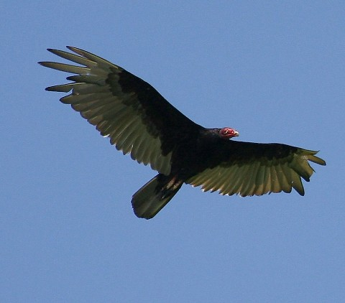
1 Northern Mockingbird
2 House Sparrow
6 House Finch
2 Anna's Hummingbird
1 Acorn Woodpecker
3 American Crow
4 White-throated Swift
4 European Starling
3 Canada Goose
5 Lesser Goldfinch
6 Black Phoebe
2 Dark-eyed Junco
3 Bushtit
1 Swallow, species
1 House Wren
2 Northern rough-winged Swallow
2 Common Raven
2 Turkey Vulture
1 Black-throated Gray Warbler
1 Red-whiskered Bulbul
1 Red-shouldered Hawk
3 Hummingbird, Selasphorus
1 Black-chinned Hummingbird
1 Mallard

--- John Beckett

Respectfully submitted,
Alan Cummings,
6/10/13

