4/17/13

Flavors are sometimes at their most intense in absence and the surprise of presence. The week after Darren comes with us, I miss the ease of his ears. We might have still ended up with most of the species Darren picks up through his hearing but he makes the searching efforts targeted. The birding is easy and it is very smooth. Others in the group have excellent hearing or know certain songs very well but none have such an aural sine qua non. With Viveca, it is all about specks. Yes, she has pattern recognition skills that yield the odd quiet perching bird that no one else can see but, what I miss in her absence, are specks. Viveca sees specks and, when she is gone, it is as if there were a feral voiding of the sky. Vicky is a fine birder but what I most feel her absence is a connection to the social fabric of a walk. She articulates an excitement, a pleasure in capture, that is infectious. Kent? To me, Kent is not about birding and it is more about presence than absence. He is about letting your mind open to contemplation or an amused but insightful comment. He is about being. He talks but he is about quiet. He reminds me of my father, with whom I could spend a day, say no more than a dozen words, and feel completely full.

Alan is the spine of the walk. He controls the pace, to a large degree, and the structure. Walks without him have a special flavor that is very tasty and invigorating but you could only take the intensity in very small doses. It is not something you would want or could even survive as a steady diet. What happens without Alan? The walk becomes slower paced and less controlled, which sometimes leads to unusually high bird counts. It should be remembered, however, that the Caltech bird walk is in the middle of the day for people who have to work for a living. We couldn't do these slow non-Alan walks on a consistent basis. The hour is there, perhaps, but Caltech's lame brained approach to vicious consequences for late time punching makes it difficult for many people to come on the walk at all and this phenomenon would be exacerbated were the walks to be any longer on average than they already are. You would think that an intellectual environment like Caltech would lead to a somewhat laissez faire attitude towards just when you were on the job but that's not the case. Lunch hours often aren't and there is a palpable fear on the part of many staff members of being late. It is a festering problem of mostly recent vintage caused by one criminal low life demanding off the clock labor of people in his group. The result? A wrist slap for the perpetrator, who should have been tossed out on his rear end with prejudice, and a shotgun blast aimed at fettering the bulk of the Caltech staff. Should we have employees living in fear of the clock? Are we actually trying to retain high quality people? One wonders.

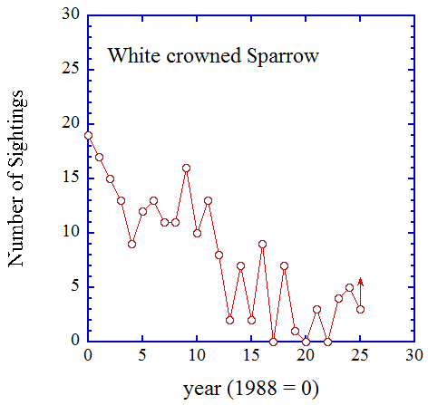
So, the walk this week was a sans Alan. The Maintenance yard, soon to be a child care center, was off limits and would have been useless even if open, given all the heavy equipment currently operating on the site. So, we decide to modify the walk route to at least partially compensate. Instead of walking to the back parking lot of the Health Center and then over to the Maintenance yard, we walk down California Blvd. to Arden and over to the front yard of the Health Center, the idea being that we would then walk up the driveway to the back parking lot, go out along the tennis courts, and then over to the playing field. With hope but not much expectation, we make the turn onto Arden and find an avian free for all. There were probably some displaced birds from the Maintenance yard mixed with migratory species and residents. The site strikes me as very well posed for birds with multiple styles of habitat. There are many sycamores, making this a likely woodpecker area, double rows of bushes with small open areas between, which makes for good towhee and sparrow hunting, good foraging opportunities for wrens, and enough seed producing flowers to attract lesser goldfinches. We spend half an hour on Arden and leave with nineteen species. We pick up another nine species over the remainder of the walk for a total of 28. This crushes the previous record of 25, set in 2011 and matched in 2012. We more than doubled the record low of 12 and we were, of course, also well above the median of 18.

See the plots at http://birdwalks.caltech.edu/bird_data/species_time.html and
http://birdwalks.caltech.edu/bird_data/two_plots.htm
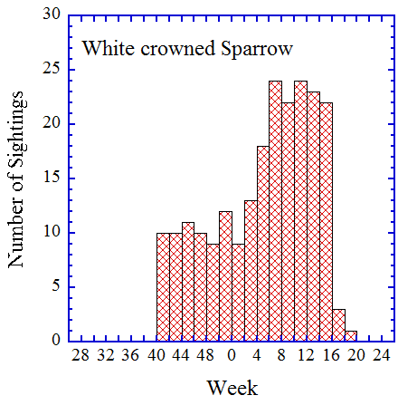
With 28 species, you can normally expect any number of highlights. We got very nice views of a downy woodpecker and a Bewick's wren. Kent somehow found a hummingbird nest well up in a sycamore, framed by leaves and complete with hummingbird, although he was less successful at getting the rest of us to a view of the cup. All of these sightings are worthy of expansion but the bird of the week is a white crowned sparrow, also observed in front of the Health center. This was our third white crowned sparrow sighting of the year and the first in more than two months. Was this a bird who spent the winter here or did we happen to intersect a passing fancy on the way north for breeding? We will probably not find out for this bird, since white crowned sparrow sightings are rare after week 16. As you might expect for a winter resident, sightings of white crowned sparrows are nonexistent between weeks 20 and 40 and peak during the winter, with a sharp drop off around the end of April as the birds leave on migration. We will most likely have to wait but I'm looking forward to testing the site for resident sparrows next winter.

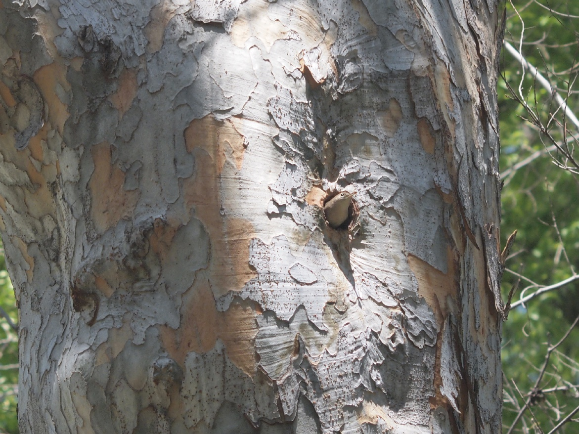
White crowned sparrows have been a species generally in decline at Caltech with sightings dropping by an order of magnitude between 1988 and ~2008, as shown in the first figure. There are some signs of a rebound, at least a rebound from nothing. I expect that Arden is going to help with our migratory sparrow count as Caltech does not have a lot of good sparrow habitat left. The Arden site could end up doubling our opportunities.

I leave you with a house wren photo taken by Ashish. House wrens are secondary hole nesters. There are currently two active holes for house wrens on the north end of Tournament Park. This one is about ten meters up. Given the camera Ashish had with him, this translates into losing bird details but the composition is first rate, giving, I think, a great sense of spatial context .

The date: 4/17/2013
The week number: 16
The walk number: 1191
The weather: 72 F, sunny
The walkers: John Beckett, Vicky Brennan, Viveca Sapin-Areeda, Ashish Mahabal, Kent Potter
The birds (28):

2 Mourning Dove
4 House Finch
2 Anna's Hummingbird
1 Acorn Woodpecker
13 American Crow
10 European Starling
30 Yellow-rumped Warbler
2 Mallard
2 White-throated Swift
1 Spotted Towhee
1 California Towhee
3 Red-whiskered Bulbul
1 Bewick’s Wren
1 Downy Woodpecker
1 White-crowned Sparrow
1 Mountain Chickadee
1 Cooper’s Hawk
6 Band-tailed Pigeon
1 Orange-crowned Warbler
1 Nuttall’s Woodpecker
10 Bushtits
2 Common Raven
2 House Wren
4 Lesser Goldfinch
2 Black Phoebe
2 Yellow-chevroned Parakeet
1 Warbler, species
1 Red-tailed Hawk

--- John Beckett

Respectfully submitted,
Alan Cummings,
6/6/13

