4/10/13

You must be careful in a trevoring dream. It can filter through a step constrained so tightly in a magic number as to bring you into thrall for another three crows or a hundred and three bushtits. You descend into the bloating of an urban pantomime from its natural padding, easing spot to spot, into a military cadence that, mastering your ambling stride, pounds from one hard slab of concrete to the next. Without much care, a bird becomes little more than the keystroke of a claiming. It has no end and no true purpose, not that it needs to have a purpose, but we are best when semi-permeable. We sidle up to a tree, heads cocked like robins waiting for a movement or a chirp. We find a nature in the interstices of edgers and the dull ranting scream of a leaf blower. We forget our grumbling whispers in a gilding nature, holding the stucco slivers of a negative space. It is a choice. We can be absorbed within or build a malodorous evaluation of ourselves. In what we leave, there is a parsing of leaf to branch to sky to grass to bind, all in a moment. It is still a bird walk. There are always birds, at least so far. I can see that you still want numbers. OK. The antiseptics say that it was not a stellar walk. They also say that it was not a terrible walk. We were held, despite our ineffectual wriggling, to 17 species, one below the median for the week (i.e., we earned a negative score) and not far above the record low of 14. The record high? I don't want to talk about it.

See the plots at http://birdwalks.caltech.edu/bird_data/species_time.html and
http://birdwalks.caltech.edu/bird_data/two_plots.htm

One highlight of the walk is the presence of two new walkers, Sok Tng and Kelly Douglas, walkers 137-138. Sok, in particular, appears to be one of those great pattern recognition types who populate the best of birding. We arrive at Tournament Park and hear a house wren. Everybody wants to see the body behind the voice but nobody can track him down through the clutter of wren colored twigs and branches until Sok spots him posted forward for prominence in the next yard. He belts out a song before dropping to forage. We have our soloist.

The three Millikan geese have been shy on Wednesdays but we finally have an official Canada goose visitation. It happened quickly, on the way to the starting point for our walk. Three Canada geese were lounging around under the bridge over the Millikan reflecting pool. They are apparently content and certainly not bothered by the presence of large numbers of humans wandering close by, reflecting high-class training in profitable goose - human interactions. Are they Arboretum birds who took a wrong turn on their annual migration to the Santa Fe Dam? There is probably no telling without a lot of DNA testing. It remains to be seen if they stick around once the weather turns but I hope they do. Canada geese are a rare sight on campus. We have just three previous sightings on the Caltech bird walk, one each in 2000, 2005, and 2011, all in weeks 43-45. This trio is a welcome anomaly.
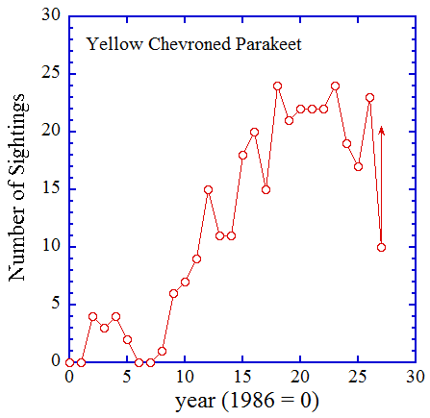
Often, a glance is enough. You see a California towhee (or a Canada goose) and have called him to your list before you can bring your binoculars to bear. You hear the rising flutter of a mourning dove and call to list before you can see anything, if you ever do. You hear the fruity voice of a red-whiskered bulbul. He will give you the pleasant visual of a pretty bird, if you see him, but you need to see nothing to know what he is. There is, however, a dark side. What you can garner in observation is not enough for a decision, no matter how hard you look or listen. The field markings are conflicting or just plain odd. The light is bad. The view is poor. The call is weird. Maybe it's a juvenile but a juvenile what? Maybe it's a vagrant but from where? Mystery birds keep you humble and interested. They can be a bittersweet leavening for a walk.
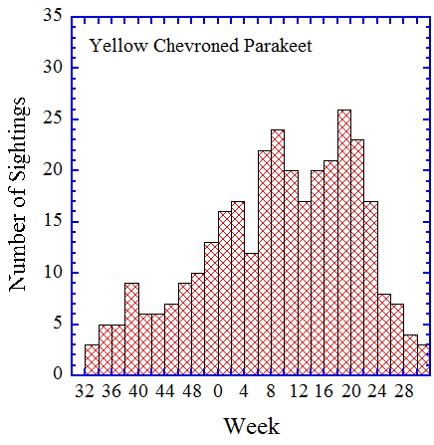
Today's mystery bird is singing patiently in a tree outside Prufrock (a graduate residence next to one of parking structures on Wilson) but very high in the canopy. It has a cowling head and light under parts, consistent with a dark eyed junco but it also has an oyster catcher orange for a bill and a song that is roundly rejected as being suitable for a junco. What could it be? In retrospect, our mystery bird probably was, in fact, a dark eyed junco but in odd lighting leading the pink bill to turn orange. The strange song was, perhaps, that of a first year bird that doesn’t quite have the proper junco way to sing completely figured out. Still, we are left with a speculative maybe and a mystery bird. He will have to remain an unknown and we will have to remain mired below the median.

In other news, the Maintenance yard is now a hard hat area and completely blocked off. Alan suggests that the rest of us storm the field (presumably, the general has in mind remaining behind to watch the troops as they nobly sacrifice themselves to the cause and to make sure that those refusing to be killed are killed). However, there are no volunteers, not that any self-respecting bird would be likely to hide in the commotion. So, we leave the burgeoning mud-lined scars of the field to the backhoes and skiff loaders and wait for a new steady state to arrive later in the year.
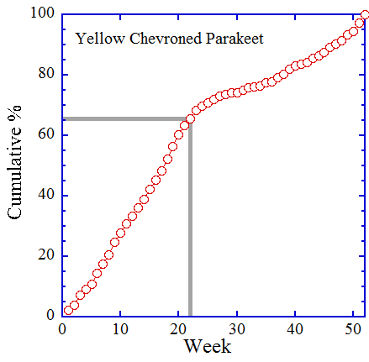
For a data bird, I suggest yellow-chevroned parakeets. We saw two but they were not a compelling capture. Two parakeets fly over the running track next to Tournament Park. Visually, we can tell that they are parakeets (green bird with long pointy tail equals parakeet) but getting to a species requires the vocalization, which is still pretty raucous but, nonetheless, tweety compared to the competition).

Yellow-chevroned parakeets are a good example of a species whose appearances on campus have increased over the years, from a few to no sightings a year before the mid-nineties, to twenty or more a year in the last decade (see first figure). The species appears, however, to be in decline, at least as far as campus visitations are concerned. 2010 and 2011 saw decidedly lower sightings frequencies. Last year was high again but this was partly driven by one bird who reliably perched in a favored Holliston silk floss tree over several weeks last spring. Without him and, perhaps, a couple Darren vocalization based calls, we would certainly have been below twenty sightings for 2012.

Yellow-chevroned parakeets can be seen at any time of the year (only week 30 currently lacks at least one sighting) but the bulk of our captures are during the winter and spring (second figure) when their favorite food, seeds in pods produced by the campus silk floss trees, are at their most edible. I note that my tardiness in producing this report means that the ten sightings shown in the first figure for 2013 refer to walks through week 22. Armed with this flush of under the table information, we can estimate the expected number of sightings for the rest of the year by plotting cumulative per cents for all 330 Caltech bird walk sightings of yellow-chevroned parakeets as a function of time (third figure). Each point on the figure represents the percentage of all sightings that occurred on or prior to a given week (e.g., all sightings occur on or before week 52, so the point for week 52 must plot at 100%). Sixty five per cent of yellow chevron parakeet sightings occur on or before week 22 as shown by the gray lines, so based on our ten sightings by week 22, we can expect roughly 10/0.65 ~15 sightings for 2013. Fifteen sightings for 2013, plotted on the first figure, would suggest a continued and, for me, a sad trend of decline for yellow-chevroned parakeets at Caltech.

The date: 4/10/2013
The week number: 15
The walk number: 1190
The weather: 77 F, sunny
The walkers: Alan Cummings, John Beckett, Vicky Brennan, Sok Tng, Kelly Douglas, Viveca Sapin-Areeda
The birds (17):

1 Mourning Dove
3 House Finch
1 Anna's Hummingbird
1 Acorn Woodpecker
8 American Crow
3 Canada Goose
1 Mallard
20 Yellow-rumped Warbler
2 European Starling
1 Lesser Goldfinch
1 White-throated Swift
1 Common Raven
1 House Wren
2 Yellow-chevroned Parakeet
1 Spotted Towhee
2 Black Phoebe
4 Bushtit

--- John Beckett

Respectfully submitted,
Alan Cummings,
6/5/13

