4/3/13

It is as if the air is pausing for a sign and the parsing of avian life hitched upon a cross hanging for a word. In the days that are longer, the dreams are more vibrant. "I am getting anxious," is a refrain from Caracas to Pasadena. "Do I leave now? Must I leave now? The insects are still flourishing but I need to leave. I must leave. Now!" The Say's phoebes and northern flickers are gone. The kettles of Swainson's hawks have worked their way up and over the San Gabriel mountains. Male black-chinned hummingbirds are in town, although we didn't see one on the walk. The females, driven by the same relentless drive, will be here over the next week or two and, if we are really lucky, the female who nested last year off Holliston has survived the winter and believes in site fidelity. It is a sign. We are in the swirling mental cacophony of the Spring migration.

It was a tough walk, given the time of year. We have been dropping two or more birds a week over the last three weeks. We didn't enhance our orange crowned warbler total and, for the second week in a row, we didn't see a ruby crowned kinglet. Did they leave early this year? It seemed a tough walk but we almost made the median of 19. It seemed like a tough walk but we nearly doubled the record low of ten. I don't care. It was a tough walk.

See the plots at http://birdwalks.caltech.edu/bird_data/species_time.html and
http://birdwalks.caltech.edu/bird_data/two_plots.htm

I suppose that a bad attitude bubbled early. We walk along the tennis courts toward the Maintenance yard, as we usually do, and are stopped by a fence blocking access and the cruel grinding of a skip loader shoving dirt at the bodies of trees. It seemed a central pyre and the raking dirt banked, as if by so doing, the half buried screams of dying trees could be silenced. They are not silent. I hear them. I hold the wave that crushes in this breasting slaughter.

We had a brief remission brewed from Caltech pondering the neighbors' legal threats but this is over. The Maintenance yard is now a construction site for the new Child Care center. It will have a capacity of ~125 children when it opens, which is an improvement over the current 99 but, of course, since a spot, assuming you get one, costs more than $20,000 a year, this is for the wealthy and well connected, a small fraction of Caltech's employees. I am not impressed. Still, I hope for future birders in the opening. Perhaps, the bounds will become part of our loop again but, for now, I have only the farewell of a pair of mourning doves fleeing the scene. They fly across the construction site like blue angels over a cemetery. They would be the pacing of a funereal dirge, were it not so noisy. Funerals are for the living, like marriages are for families, but construction sites are not for birds. Bird populations drop dramatically within a block or so of a big construction site. Tournament Park, which is close by is likely to be trying for a while.

The Millikan geese have become a big tease. They are often on campus at 9 AM but leave between 10 and 11 AM. I suspect that they fly off to some other watering hole opening to humanity at 11 or 12 that has better shade. Naturally, the day after this week's walk, the geese decide to stay through the lunch hour (i.e., if they had done that on Wednesday, we would have bagged them).

In other news, the mallard drake (= male) is back after being absent for a week but the hen is not. A likely scenario is that he escorted the hen he has been accompanying for the last couple of months to look through the local real estate for nesting spots and then stayed with her until she started laying eggs or, at least, began constructing her nest. After that, he had no further genetic interest in the affair, which allowed him to return to Caltech and its free cat food. Our drake shares no nesting duties and he doesn't provide any care for the young. His primary role during the breeding season is to drive off other males, thereby, demonstrating fitness. From the hen's perspective, it's basically, "I like your looks and, if you are strong enough and persistent enough to keep all the other drakes at bay, I will choose you as my mate." Pair bonding generally takes place during the winter. In this case, our happily married pair chose to reduce competition by selecting an isolated spot with good amenities (lots of food and just enough water to keep toddlers from getting too close). Another drake (occasionally two) hung around this winter, hoping to sneak off with the hen but, as breeding season approached, he drove them off.
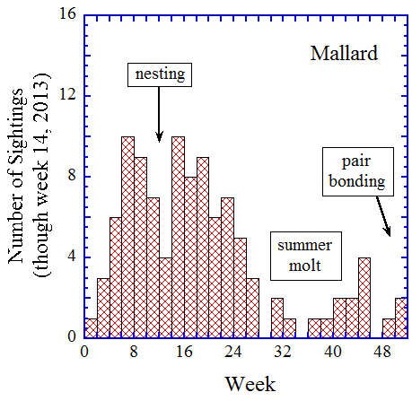
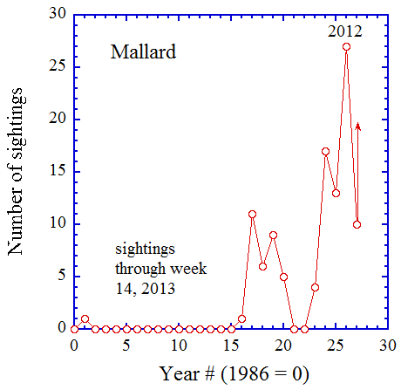
The keys to mallard success are late winter food, nesting habitat, and a place to hang out during the summer molt. From a Caltech perspective, we have very good food. There are people who feed the ducks directly, some aquatic livestock that can be strained out of the muck in the ponds, and cat food put out for the campus feral cats, which ducks, cats, and squirrels all eat. Our day safety water features are passable but the night safety is not great and we have no large bodies of water that can be used during molting. Mallards molt during the summer. First the body feathers go (if your duck looks ratty, this is probably why) and then, in a big whoosh, a mallard will lose his/her primary flight feathers. Without the primaries, a mallard is basically flightless, so a large body of water with lots of cover becomes important. Given these duck life realities, Caltech is most attractive during winter after pair bonding and in the Spring after nesting. There is a low in sightings around weeks 10-14 that is likely to be associated with nesting and there may be a small migration pulse in weeks 40-46 (many mallards still migrate up and down the Pacific flyway). Summer sightings are sporadic, in part, because the number of flight worthy ducks at any given time is greatly suppressed relative to winter. Also, the ducks tend to stick to their summer molting areas, which have good food stocks until the Fall, even though they can, by the end of summer, fly quite well.

The second figure shows the number of mallard sightings as a function of time. We had one sighting in 1987, a clear freak because the next sighting was 15 years later in 2002. Duck sightings were modestly common (several a year) between 2003 and 2006. Then, starting in 2009, the sightings rate ramped steadily upward. These more recent sightings almost certainly derive from different ducks than the 2003 - 2006 crowd (or duck). I have little doubt that the main attractive force is winter food and, I suspect, that a key ingredient is cat food.

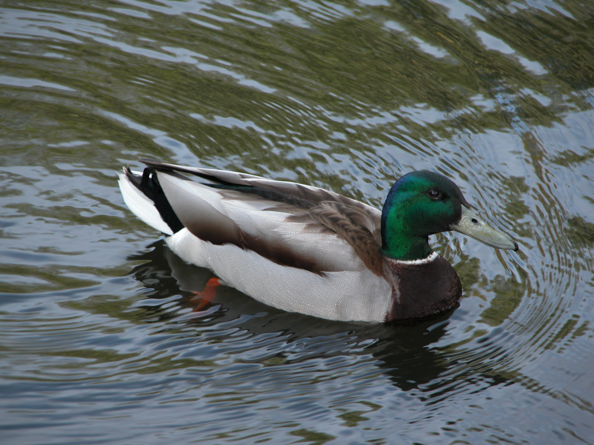
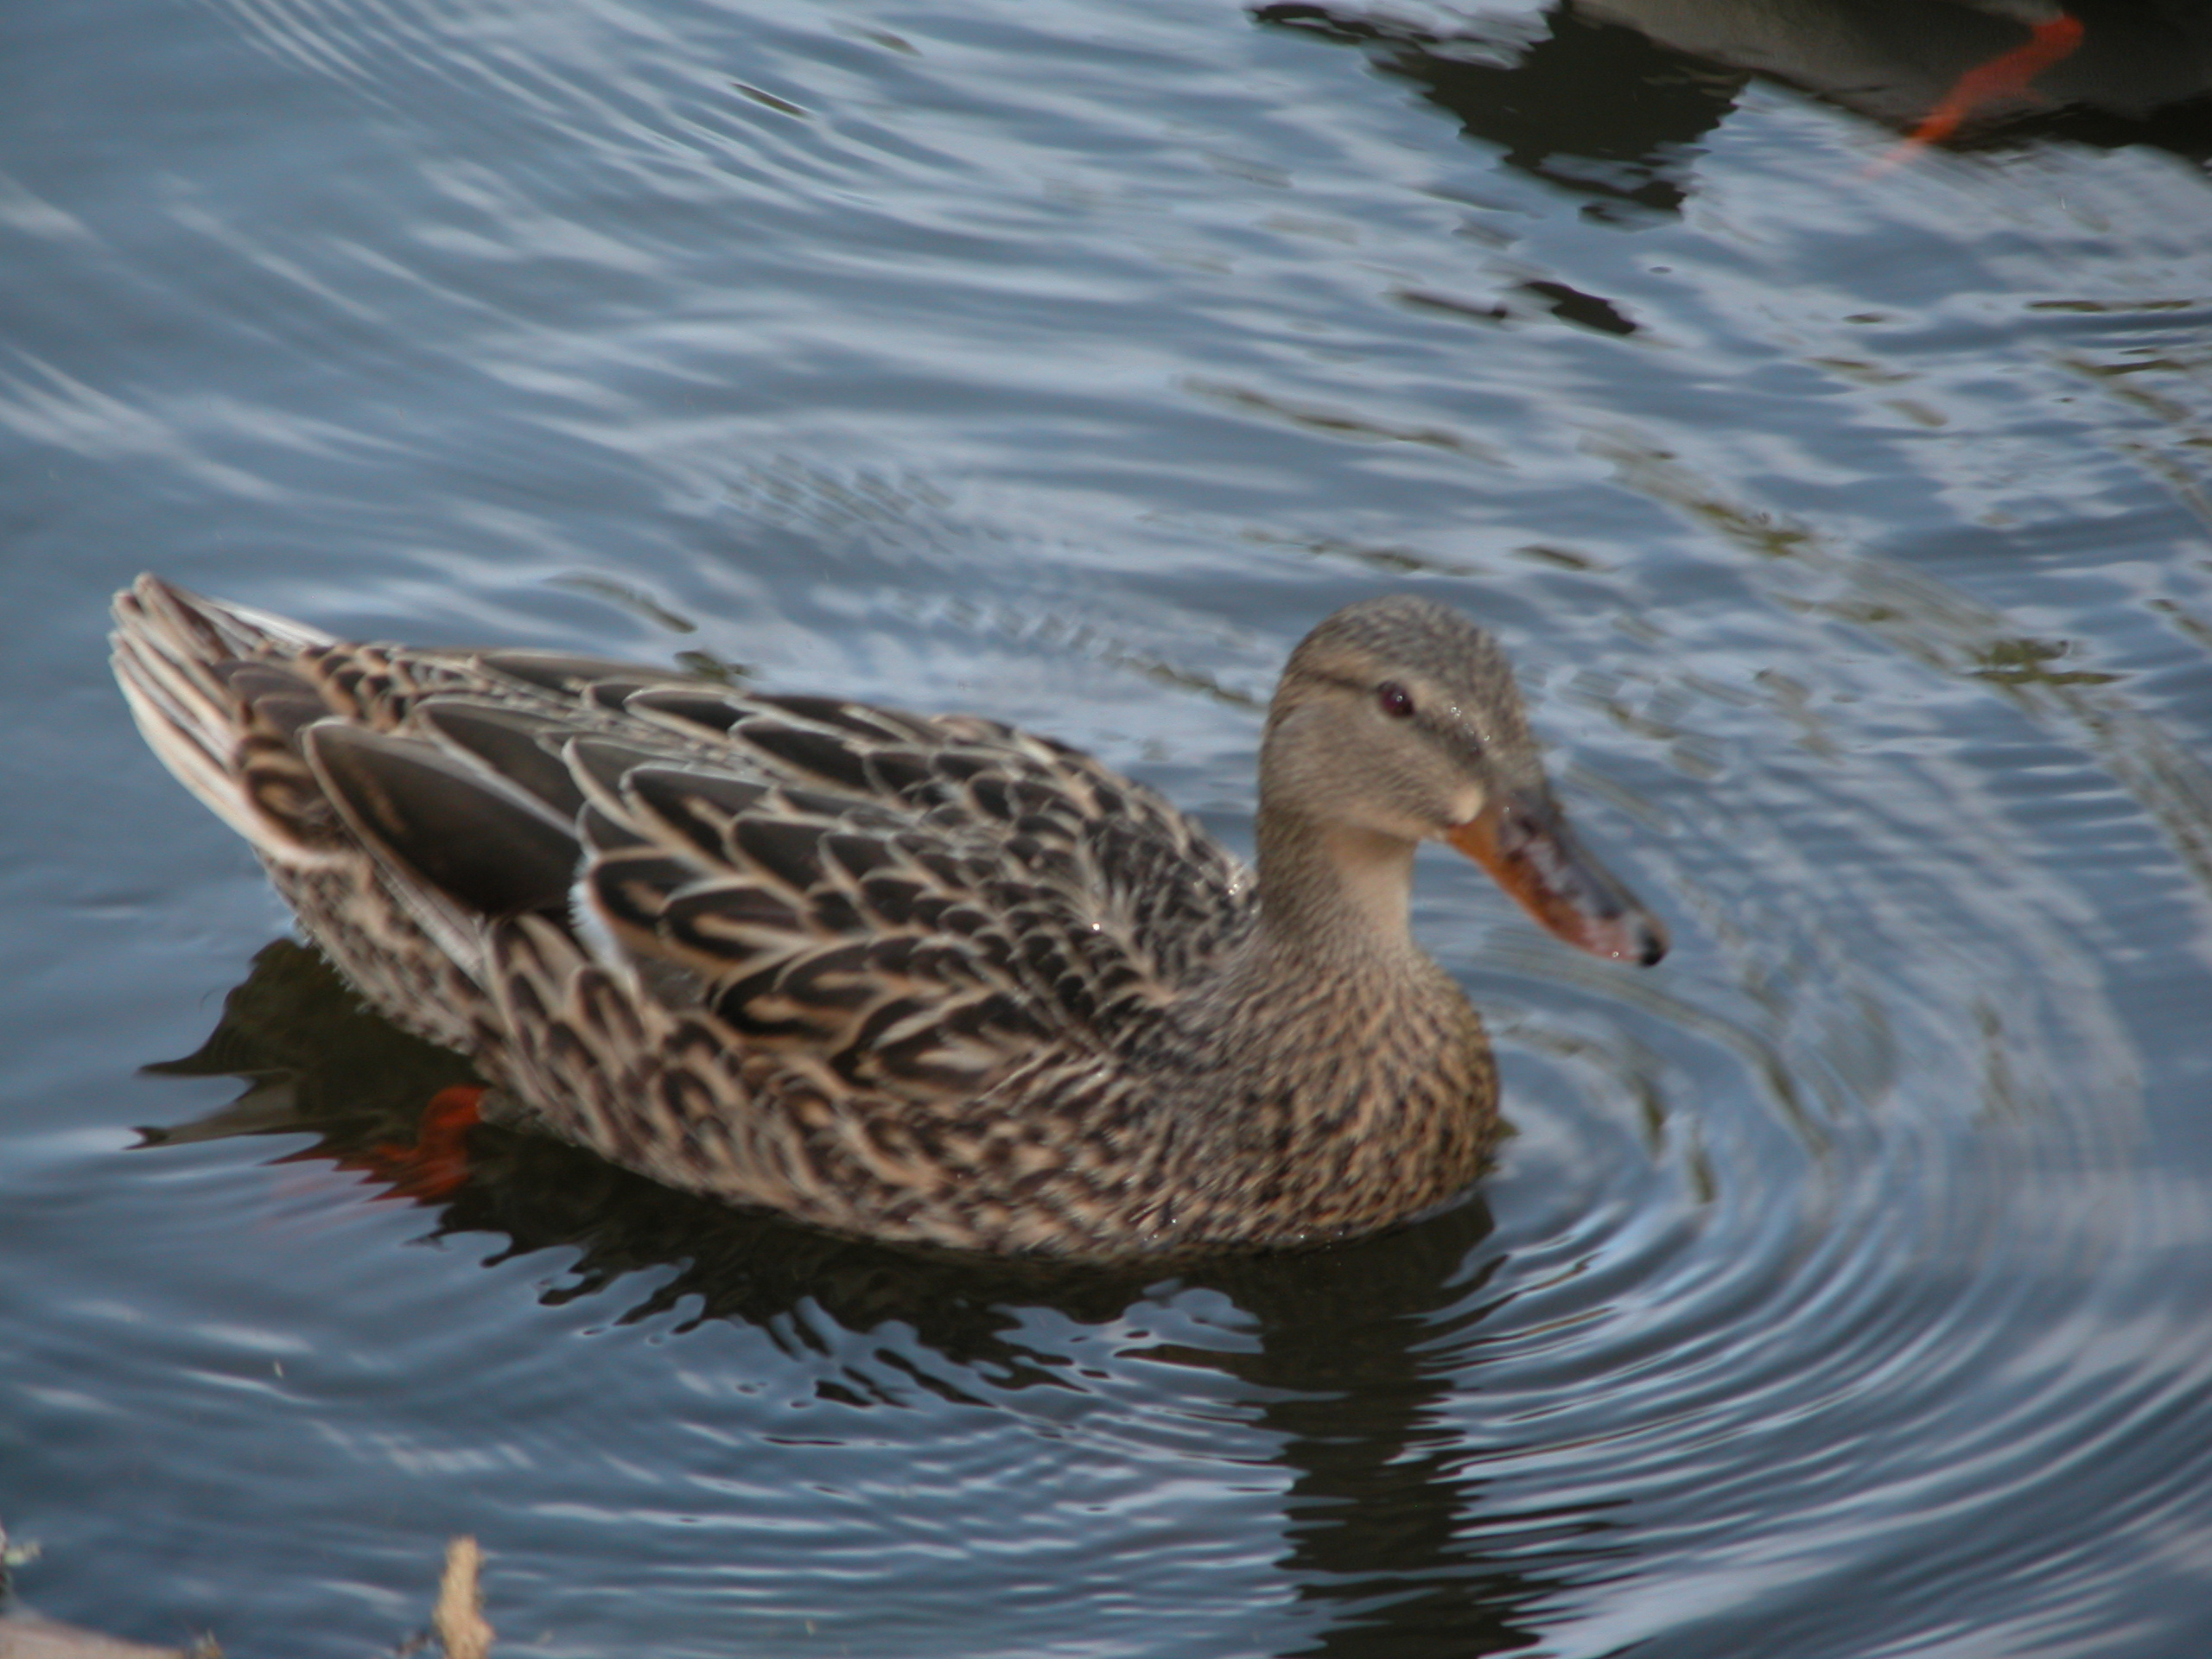
For pictures, I think I will just offer a pair of mallards (drake to the left and hen to the right), even though they are the bird of the week. Identifying female ducks in the absence of a male of the same species, can actually be rather challenging and, if we were trying to set up a gallery for the San Gabriel Valley, I would have to be much more circumspect. However, the only duck on the Caltech bird list is the mallard so, until a ring necked duck decides to show up on campus, we can be cavalier. These are both Arboretum winter ducks (January) looking for a hand out (they didn't get one). Finally, I leave you with a tuckered mallard from Bolsa Chica (March).

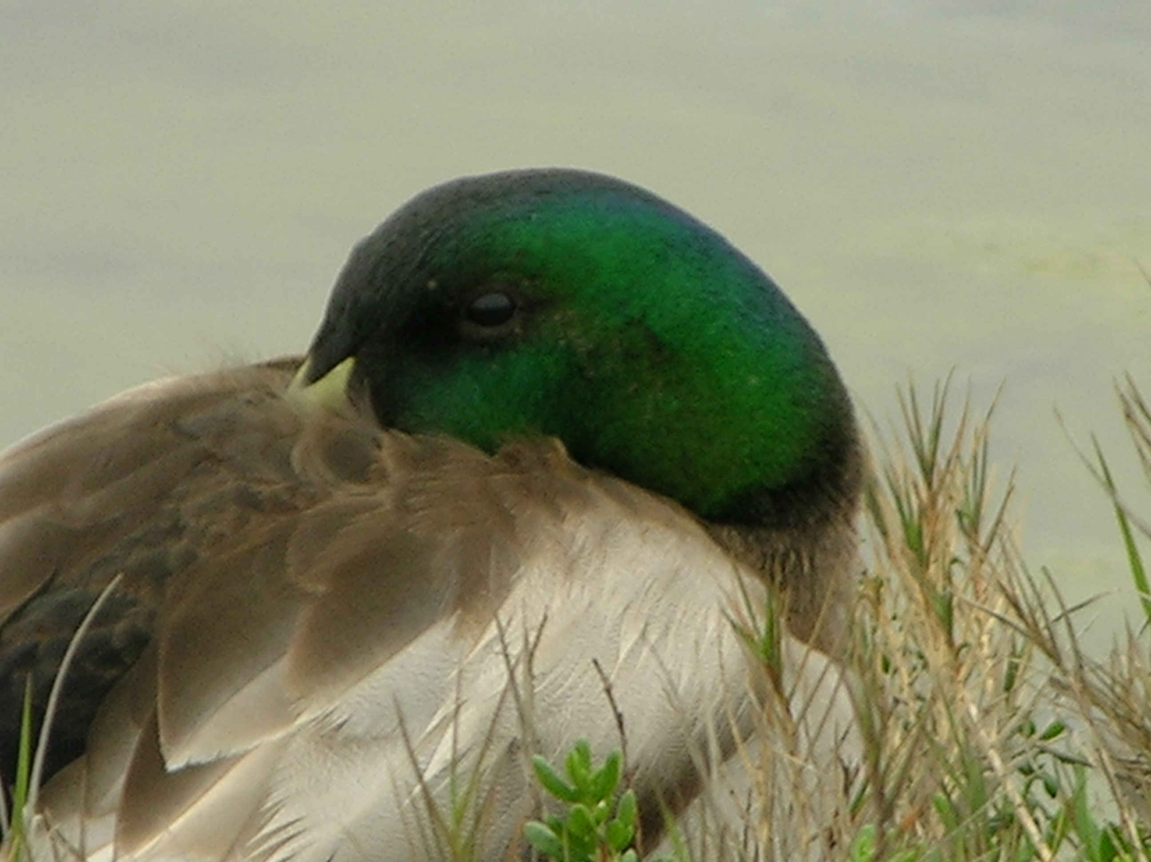
The date: 4/3/2013
The week number: 14
The walk number: 1190
The weather: 75 F, partly cloudy
The walkers: Alan Cummings, Carole Worra, Vicky Brennan, John Beckett, Viveca Sapin-Areeda
The birds (18):

1 Northern Mockingbird
2 Mourning Dove
6 House Finch
2 Anna's Hummingbird
6 American Crow
1 Mallard
1 Red-whiskered Bulbul
1 Spotted Towhee
11 Yellow-rumped Warbler
1 Swift, species
5 Bushtit
4 Lesser Goldfinch
1 Mountain Chickadee
3 Black Phoebe
1 Woodpecker, species
1 Hummingbird, Selasphorus
1 Sparrow, species
2 Common Raven

--- John Beckett

Respectfully submitted,
Alan Cummings,
4/11/13

