3/27/13

Every walk carries a flavor that brings itself into its own regime. The species total was not special. The record for the week is the record for the walk, 37, set in 2011, the last and greatest of four straight weeks of 30+ walks. We landed with a precise step onto the median of 20.

See the plots at http://birdwalks.caltech.edu/bird_data/species_time.html and
http://birdwalks.caltech.edu/bird_data/two_plots.htm

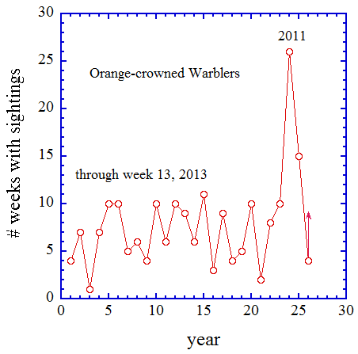
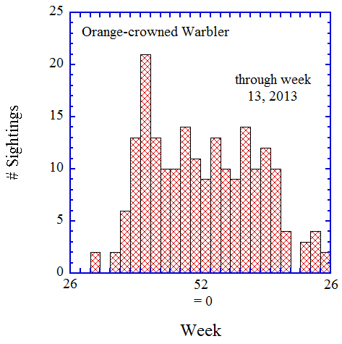
Vicky saw a mountain chickadee in the Maintenance yard in the midst of a swirling mayhem. Her bird tempts but I yield the bird of the week through a dungeon call. Most of the Maintenance yard has been graded to level with the parking lot backing the tennis courts but this leaves a depressed rim in the southwest that drops some three meters to the level of the neighbors. Within these depths is an unruly mop of a yard. It rarely offers birds at ground level but it gives a different and, sometimes, very productive view up into the canopy. This time Alan and Kent pick up an orange crowned warbler, who yielded only the flimsiest of clues to the rest of us standing on the plateau. Orange crowned warblers are special birds for us. They are at once nondescript and inviting. They teach subtlety. They are one of the intriguing aspects of birding. You walk within a force of patterns that crumble the expected loosening plaster of bright contrasts. For a more subtle bird, you have to pay attention. You have to unblend a well-blended bird.

Setting aside 2011-2012 for the moment, you can see from the first figure that there is a distinctive saw-tooth pattern to orange crowned warbler sightings. We sometimes get a couple of successive years with circa ten sightings a year but we inevitably fall back into a year or two with circa five (or less) sightings year. Prior to 2011, there was no obvious trend up or down overall, which suggests a stable pattern. If you compare lean and fat years, however, you do find a difference. In both lean and fat years, we generally pick up a few orange crowned warblers on migration but, in a sightings rich year, we will see them in the winter. About half the time, we have multiple winter residents on campus and about half the time we don't. These are not long-lived birds and site fidelity is not perfect, so we find ourselves in a saw tooth. In 2011 and 2012, we found ourselves consistently picking up orange crowned warblers throughout the winter. What made these years extraordinary is the presence of warblers in the summer. This can happen because orange crowned warblers from the Channel Islands winter and breed on the Channel Islands but summer on the mainland after their cousins, who wintered here, have migrated up to Alaska for the breeding season. There is little physical overlap between the two populations. Usually, the Channel Island warblers summer closer to the coast than Caltech, so we only see them rarely but, in 2011, we had at least two of these birds decide to summer on campus. This year, we have, with this week’s contribution, four sightings for the year. If we pick up another bird or two over the next few weeks and have a decent Fall, this will be another good year for orange crowned warblers. If we get a Channel Island warbler summering on campus, we may have a stellar year. It seems to me unlikely that we will be so blessed with a Channel Island bird, given the likely construction at the Maintenance yard, but who knows. Maybe, we will be lucky.

We can glimpse the realm of possibilities for the rest of this year from the second figure. This shows sightings by week with a two-week bin. As for other birds that winter at Caltech, you (or at least I) get a better sense of a year from the birds’ perspective by plotting sightings from summer to summer rather than by calendar year. In the Spring, sightings drop precipitously after week 18 but we still have a decent shot at seeing at least one more orange crowned warbler before summer. The Fall migration will bring orange crowned warblers back to us from Canada and Alaska around weeks 37-40 as juveniles, and then adults, pass through campus. Some small fraction of these birds will decide to winter here and we will, at least occasionally intersect one of them.

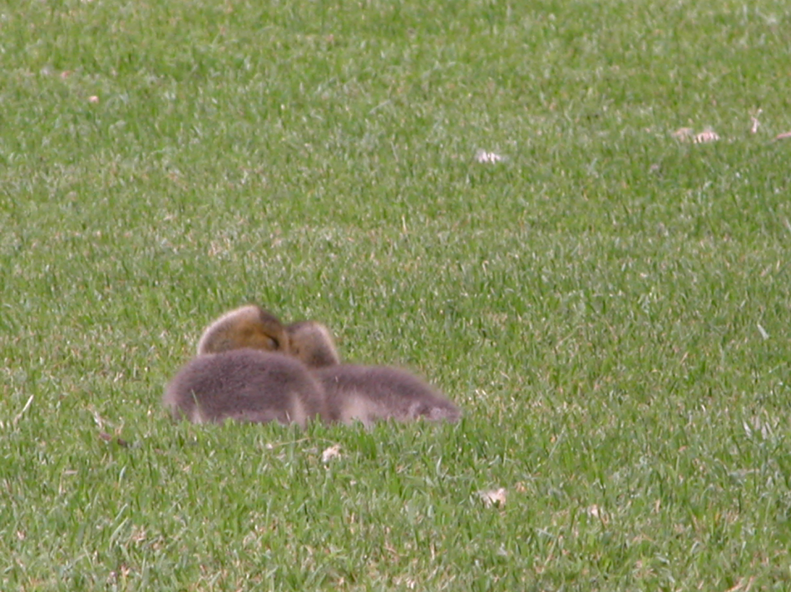
You may have noticed my recent use of figures and pictures in the walk report. I am thinking that these should be decoupled. That is, the plots will be tied mostly to the bird of the week. For the photos, however, I wanted to be freer. I may choose to be visually expansive about the bird of the week but I don't want to be restricted to that format. Long term, the basic goal is to build a gallery of bird photos with associated descriptions and identification trails that can be used by anyone to aid in the identification of birds known to have visited the campus. I am in no hurry and I have no particular focus while I am collecting my way to a full gallery beyond trying to get something for at least one new bird a week. I may choose photos to illustrate some feature of identification as I did a couple of weeks ago with the downy and Nuttall's woodpeckers or last week with sexing of bushtits. This week, I do something a little different and begin with a teaser. I took this shot at the Los Angeles Arboretum in January of 2006. Care to guess? If you are thinking ducklings, that's a good try (but the coloring is wrong). This is a pair of goslings.

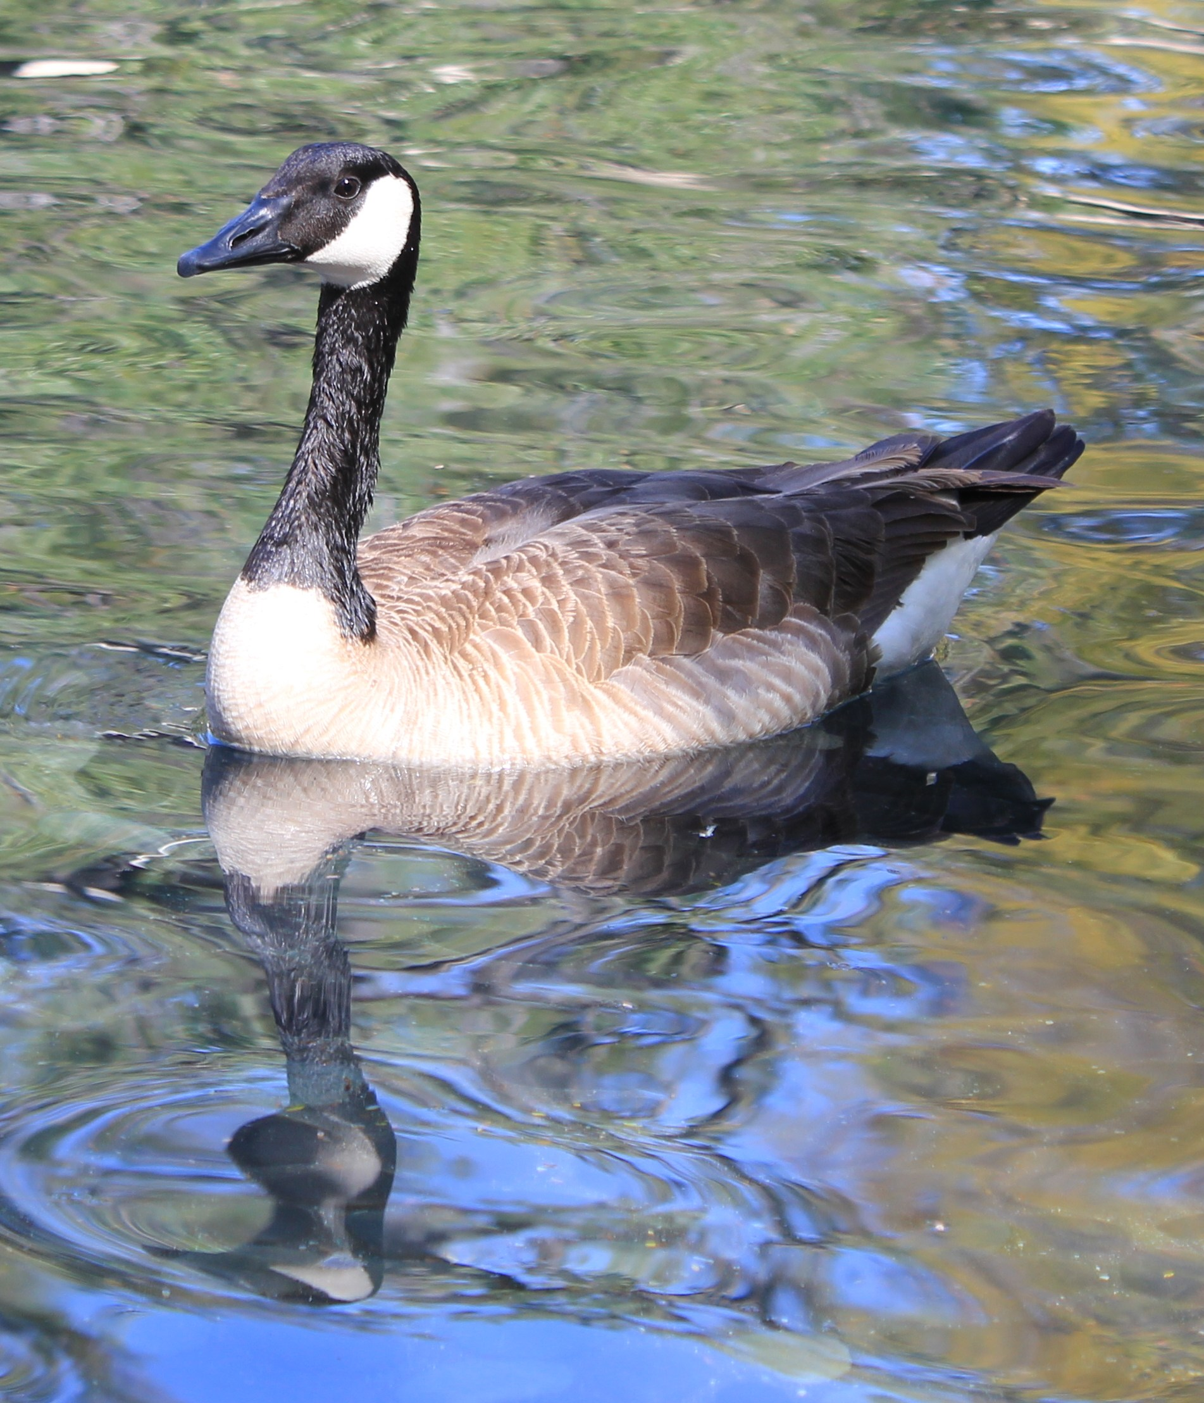
This week, but not our walk, featured a trio of adult Canada geese. Unfortunately, they didn't honk their way onto campus during lunchtime on Wednesday but, on Thursday, they are lounging around the Millikan reflecting pool and the adjacent walkways and lawn. They are the biggest avian thing to land on campus since the great blue heron of 2011. These geese are clearly used to humans, as people wandering within a foot of them provoke no sense of consternation, only a sense of potential opportunity. I found myself right next to one of these birds. We happened to be walking in opposite directions on the veranda leading to the Millikan library entrance. I look down and realize that I have just passed a goose with, I would say, much less than a foot to spare. The goose thought nothing of it. Somebody, somewhere, has been feeding these birds. This photo, taken by Peter Mao, shows one of them cruising the Millikan reflecting pond on Thursday (i.e., the day after the walk).

The general consensus seems to be that permanent residency of Canada geese at Millikan would be problematic for Caltech. The walkways on the two sides of the Millikan reflecting ponds are high use and permanent geese would bring considerable of fouling of both the walkways and adjacent lawn areas. It is, however, up to the geese (and ultimately, perhaps, the grounds crew) to decide whether or not the local amenities deserve an extended stay.

The date: 3/27/2013
The week number: 13
The walk number: 1189
The weather: 63 F, partly cloudy
The walkers: Alan Cummings, Eric Christian, John Beckett, Kent Potter, Vicky Brennan
The birds (20):

1 Scrub Jay
1 Mourning Dove
10 House Finch
1 Anna's Hummingbird
5 American Crow
2 Common Raven
6 Yellow-rumped Warbler
6 Black Phoebe
1 European Starling
1 Red-whiskered Bulbul
20 Lesser Goldfinch
1 American Goldfinch
1 Hummingbird, Selasphorus
1 Orange crowned Warbler
1 Mountain Chickadee
1 Red-breasted Sapsucker
2 Band-tailed Pigeon
1 Bewick’s Wren
15 Bushtit
1 Red-shouldered Hawk

--- John Beckett

Respectfully submitted,
Alan Cummings,
4/10/13

